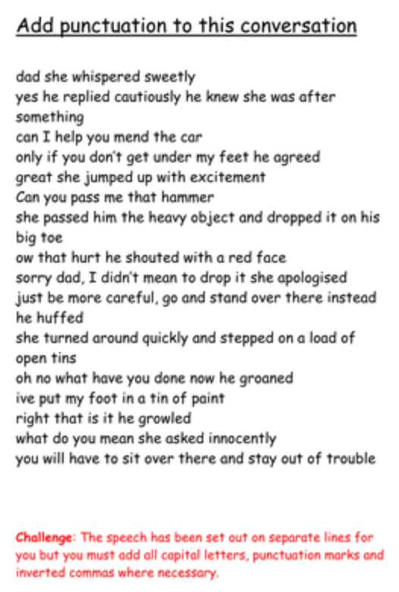

Answers

“Dad,” she whispered sweetly.
“Yes,” he replied cautiously. He knew she was after something.
“Can I help you mend the car?”
“Only if you don’t get under my feet,” he agreed.
“Great!” She jumped up with excitement.
“Can you pass me that hammer?”
She passed him the heavy object and dropped it on his big toe.
“Ow, that hurt!” he shouted with a red face.
“Sorry, dad. I didn’t mean to drop it.” she apologised.
“Just be more careful. Go and stand over there instead,” he huffed.
She turned round quickly and stepped on a load of open tins.
“Oh no. What have you done now?” he groaned.
“I’ve put my foot in a tin of paint.”
“Right, that is it,” he growled.
“What do you mean?” she asked innocently.
“You will have to sit over there and stay out of trouble.”

