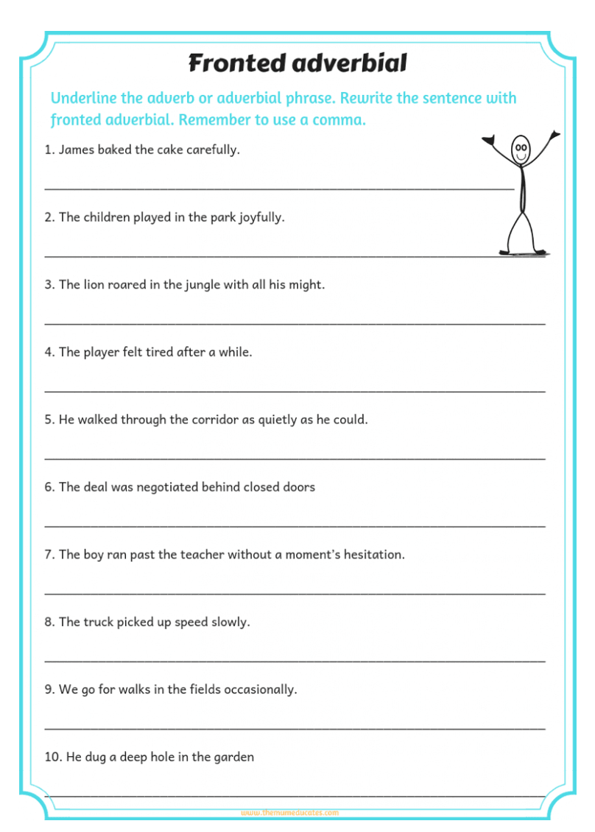

Challenge - write some fronted adverbial sentences for the picture.

Answers

- Carefully, James baked the cake.
- In the park, the children played joyfully /
Joyfully, the children played in the park.
- With all his might, the lion roared in the jungle. /
In the jungle, the lion roared with all his might.
- After a while, the player felt tired.
- As quietly as he could, he walked through the corridor.
- Behind closed doors, the deal was negotiated.
- Without a moment’s hesitation, the boy ran past the teacher.
- Slowly, the truck picked up speed.
- Occasionally, we go for walks in the park.
- In the garden, he dug a deep hole.

