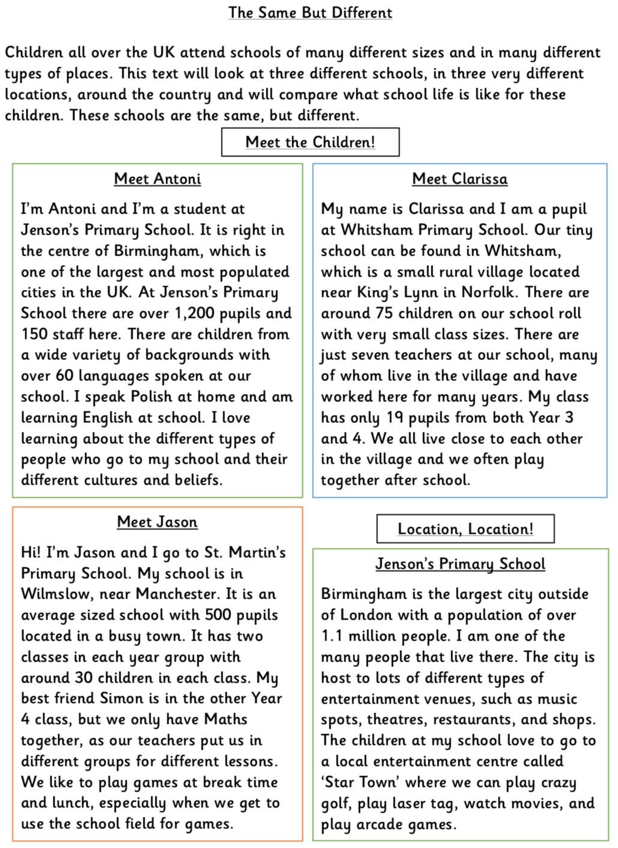
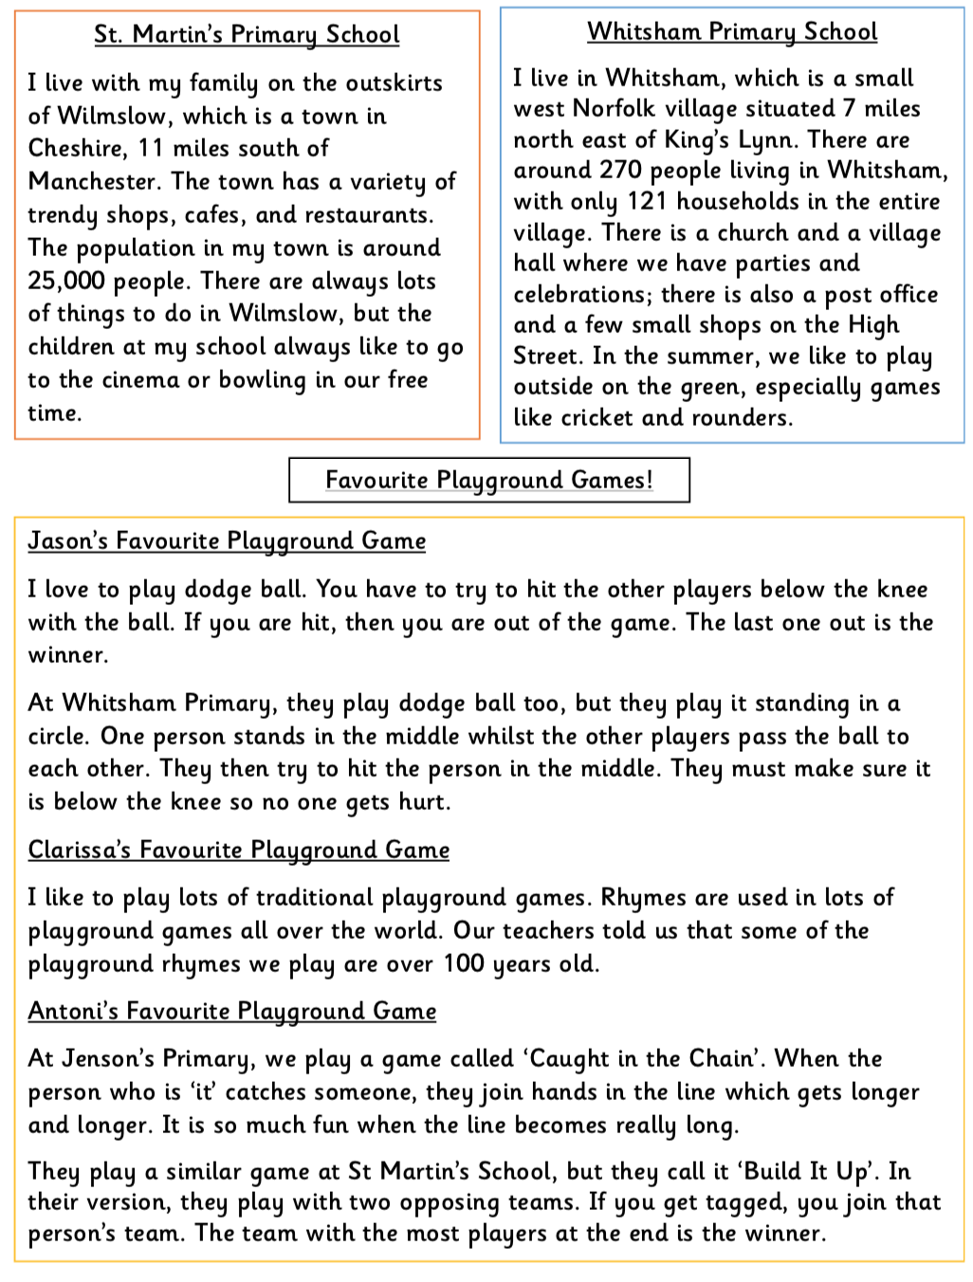

1. How many children attend Jenson’s Primary School?

2. Why do you think there are so few pupils attending Whitsham Primary School?

3. What sorts of activities can be completed at ‘Star Town’ in Birmingham?

4. Birmingham has a population of over 1.1 million. Use a dictionary to find the meaning of ‘population’.

5. Which of the three schools is most like your school? Explain your answer.

6. What does the word ‘opposing’ mean when referring to two opposing teams?

7. Using evidence from the text, how do the entertainment opportunities vary between Whitsham and Birmingham?

8. What do you think is meant by the phrase ‘the same, but different’?

9. What does the word ‘trendy’ tell you about the shops and cafes in Wilmslow?

10. Summarise the differences between ‘Caught in the Chain’ and ‘Build It Up’.

11. What evidence is there to show Jenson’s Primary School is a multi-cultural school?

ANSWERS
- 500 Pupils go to Jenson’s Primary School.

- There are so few pupils at Whitsham Primary School but it is in a small village with only 270 people living there.

- Activities that can be completed at Star Town are – crazy golf, play laser tag, watch movies and play arcade games.
- Population means all the inhabitants of a particular place.

- St Martin’s Primary School is most like ours because it on the outskirts of a city, Durham, and

- The word opposing means in conflict or competition with someone or something.

- Birmingham is a large city with many different entertainment venues, such as music, sport, theatres, cinemas and shops. Most activities take place indoors. In contrast, Whithsham, being a small village, has just a few shops and most celebrations take place in the village hall. The activities enjoyed in Whitsham are mostly outdoors in summer as there is lots of land around about,

- ‘The same but different’ means that everyone does the same sort of things but just in different ways.

- The word trendy tells me that it is modern, fashionable or very up to date.

- The difference between Caught in the Chain and Build It Up are that in Caught in the Chain, there is one line, which a tagged person joins. In Build it Up there are two teams playing against each other and the person tagged joins the team of that tagger. The team with the longest line at the end wins.

- The evidence that Jenson’s school is a multi-cultural school is it is a very large school with people from a variety of different backgrounds and children can speak over 60 different languages. Antoni himself speaks Polish at home.

