Activity 2 – Subtract two four-digit numbers

1. Complete the calculations
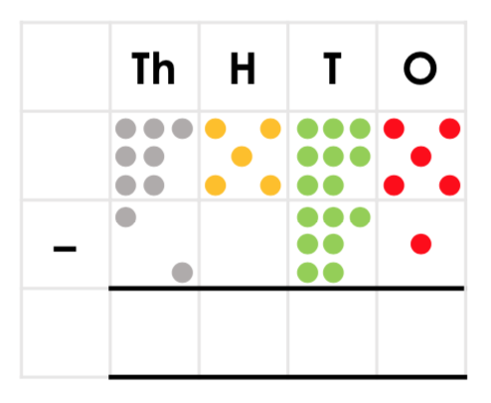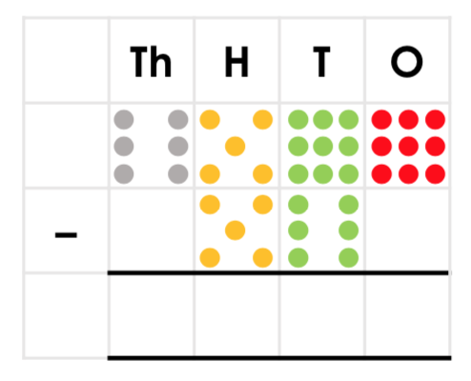
2. Draw the missing counters.
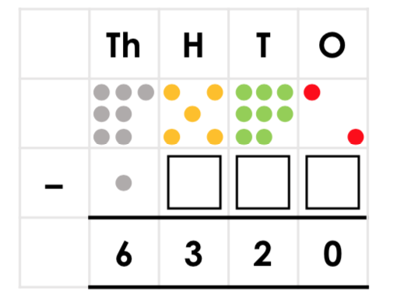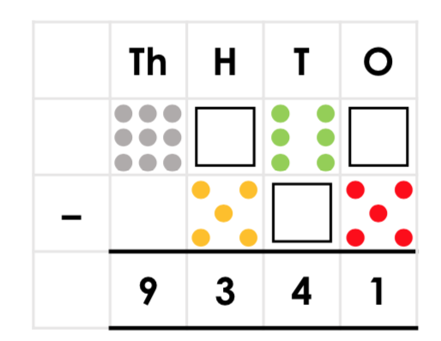
3. Find the missing numbers for each bar model.
9045
4012

5631
2410

4. Find the missing number for each part/whole model.
4613
7426

201
?
?
4213

5. Use the <, > or = symbol to complete the number sentences below.

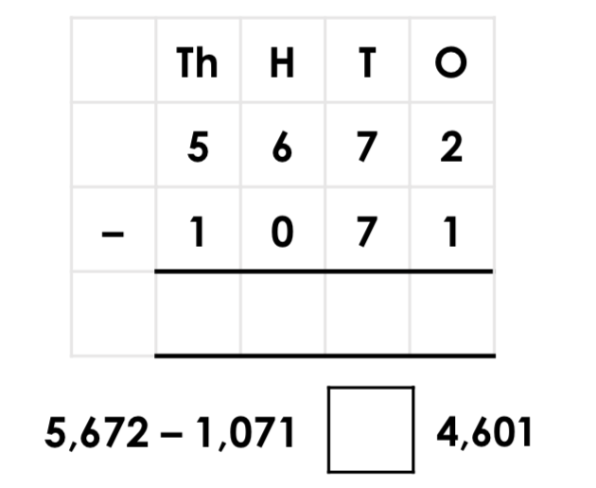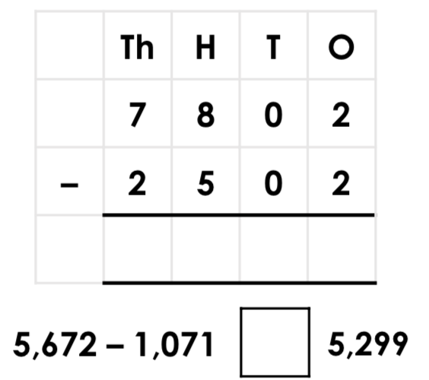

Answers

1) 5,514
6,039
2) 2 counters in the hundreds column, 6 counters in the tens column, 2 counters in the ones column.
8 counters in the hundreds column, 2 counters in the tens column, 6 counters in the ones column.
3) 3221
5033
4) 3213
4412

5) 4,601 = 4,601
5,300 > 5,299

