Activity 2 – Multiply by 6

1. Complete the calculations to match the array below.  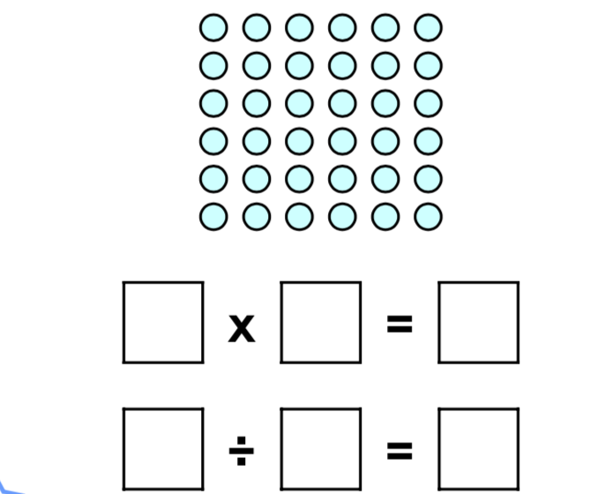 | 2. Complete the calculations to match the array below.  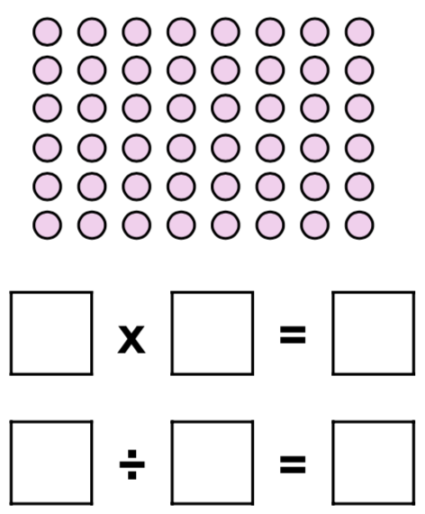
3. Which bar model which correctly represents the calculation below.  9x 6  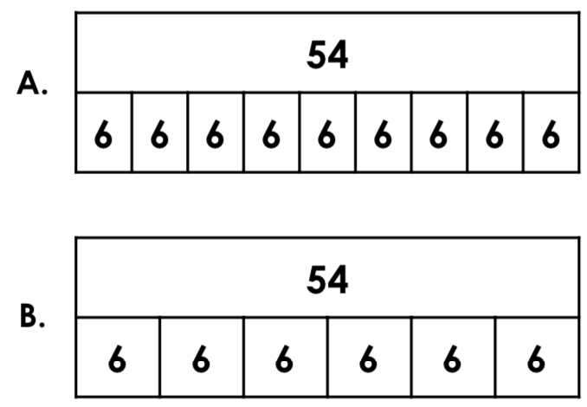 | 4. Which bar model which correctly represents the calculation below.  3 x 6  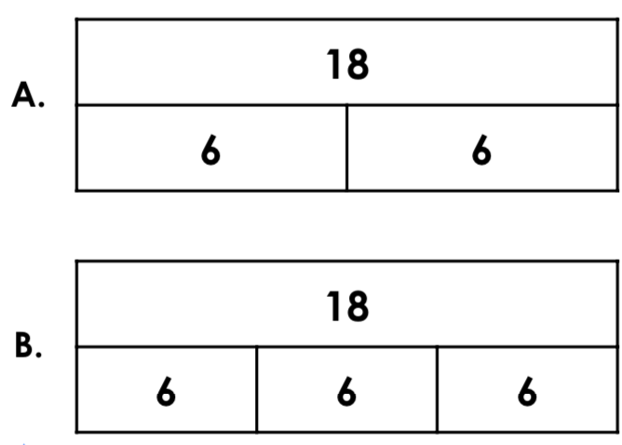
5. Susie has 24 sweets. She shares them equally between 6 jars. How many will there be in each jar?  Draw the sweets in the jars below.  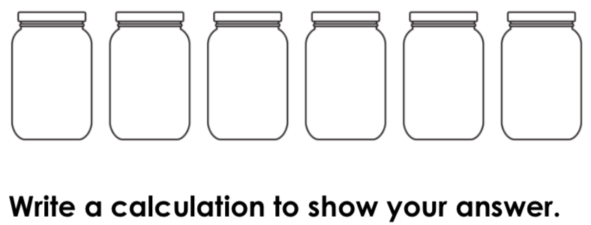 | 6. Susie has 24 sweets. She shares them equally between 6 jars. How many will there be in each jar?  Draw the sweets in the jars below.  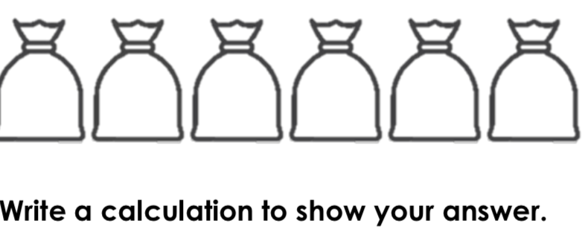
7. Match the calculation to the correct bar model.
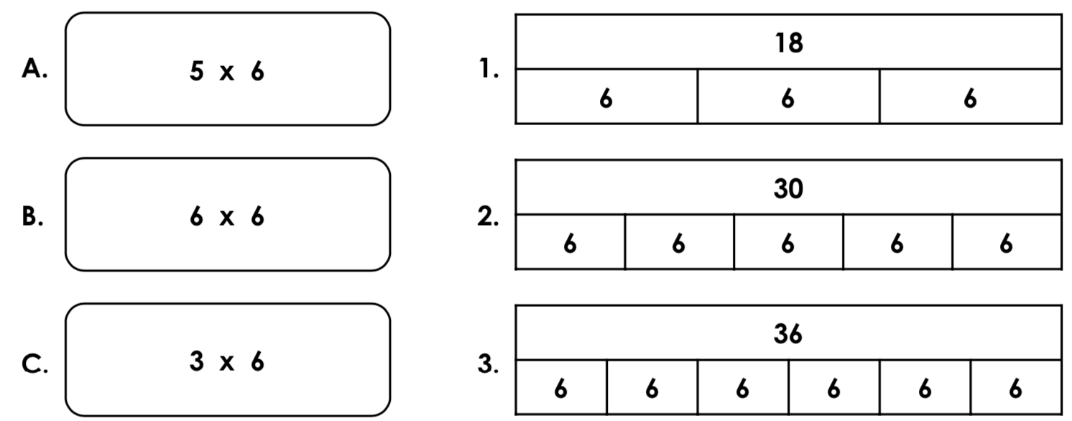
8. Match the calculation to the correct division fact.
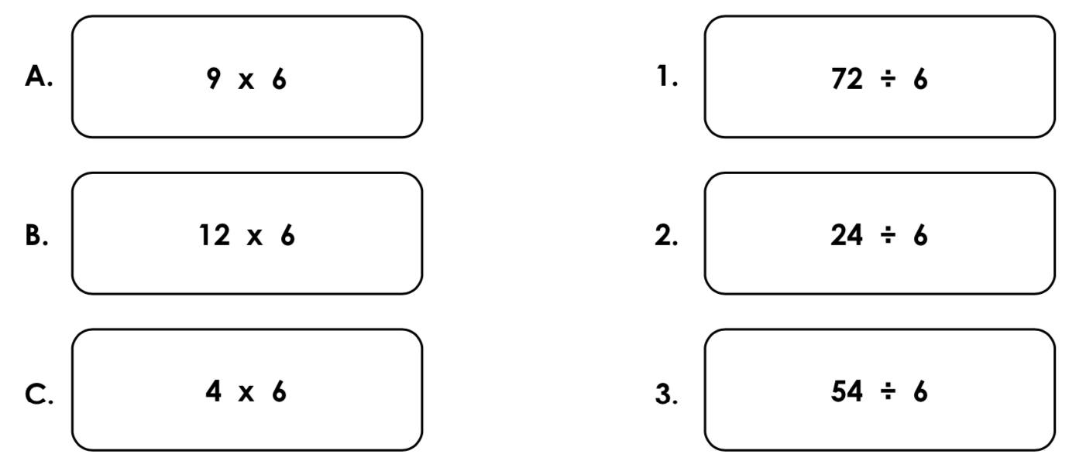

Answers

- 6 x 6 = 36, 36 ÷ 6 = 6
- 8 x 6 = 48, 48 ÷ 6 = 8
- A
- B
5) 4 sweets in each jar; 24 ÷ 6 = 4
6) 6 marbles in each bag; 36 ÷ 6 = 6
7) A – 2, B – 3, C – 1
8) A – 3, B – 1, C – 2

