Activity 2 – Inverse operation

1. Use an inverse operation to calculate each missing number.  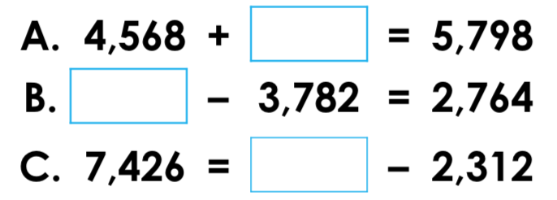 | 2. Use an inverse operation to calculate each missing number.  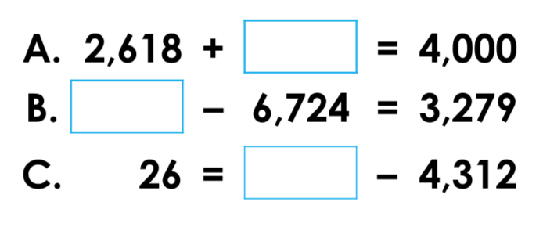
3. Use the calculation below to create two related number sentences.  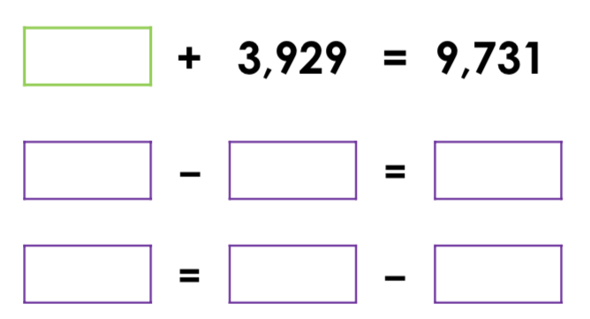 | 4. Use the calculation below to create two related number sentences.  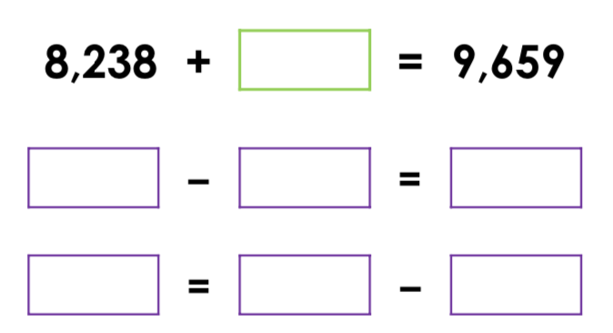
5. Complete the bar model.  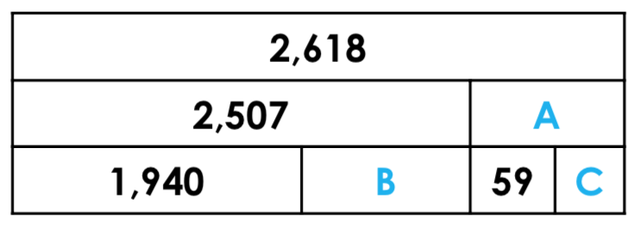 | 6. Complete the bar model.  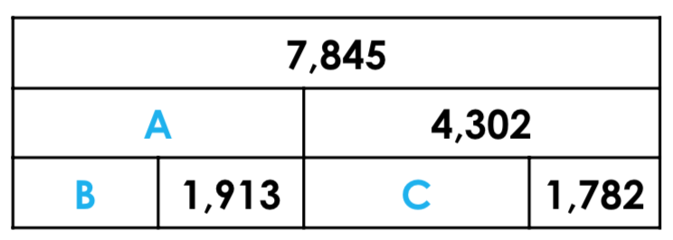
7. Use an inverse operation to find the correct calculation.  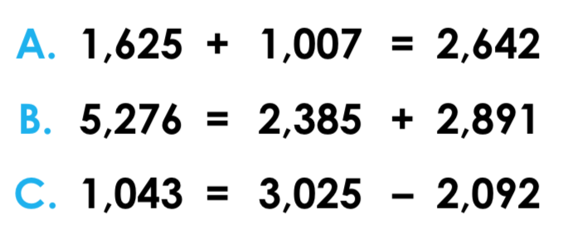 | 8. Use an inverse operation to find the correct calculation.  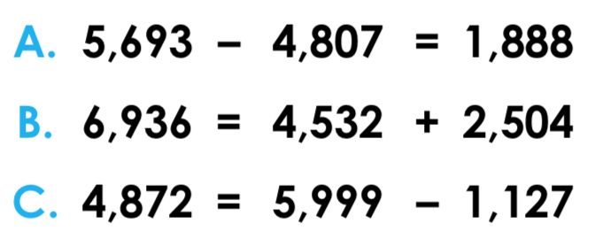

Answers

1) A = 1,230: B = 6,546: C = 9,738
2. A = 1,382; B = 10,003; C = 4,338
3. 5,802 + 3,929 = 9,731; 9,731 – 3,929 = 5,802; 3,929 = 9,731 – 5,802
4. 8,238 + 1,421 = 9,659; 9,659 – 8,238 = 1,421; 8,238 = 9,659 – 1,421
5. A = 111; B = 567; C = 52
6. A = 3,543; B = 1,630; C = 2,520
7. B; 5,276 – 2,891 = 2,385
8. C; 4,872 = 5,999 – 1,127

