Activity 2 – Subtract two four-digit numbers (one exchange)
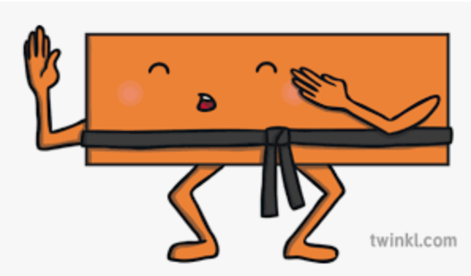

1.True or false? The difference between 8,214 and 3,192 is 5,022.  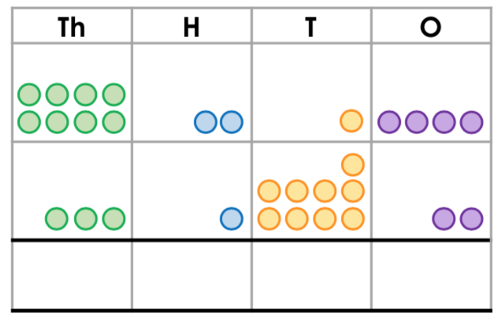 | 2. True or false? The difference between 6,028 and 1,904 is 5,924.  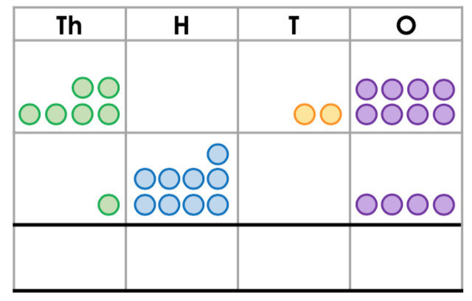
3. Find the missing numbers for the bar model.  5147  1065 | 4. Find the missing numbers for the bar model.  3729  1756
5. Circle the correct answer to the question below.  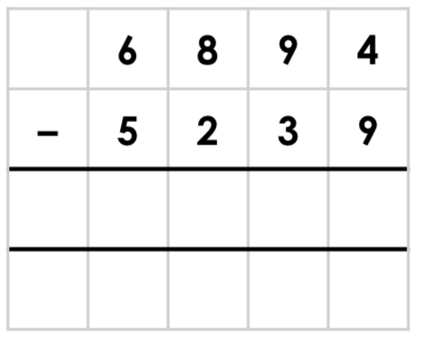  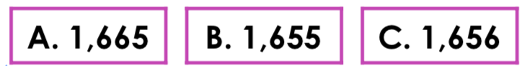 | 6. Circle the correct answer to the question below.  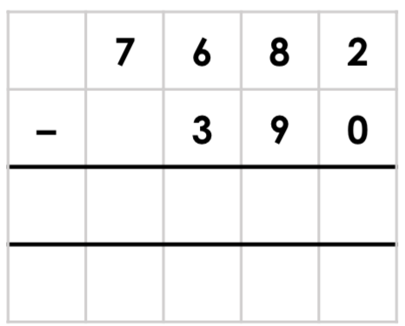  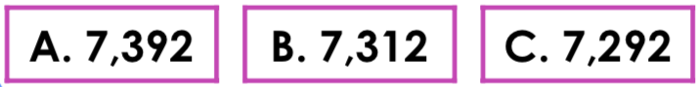
7. Find the missing numbers in the part/whole model.  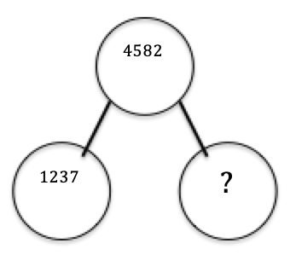 | 8. If Maggie has 4,825 beads and she gives 2,913 of them to Bea, how many beads does she have left?  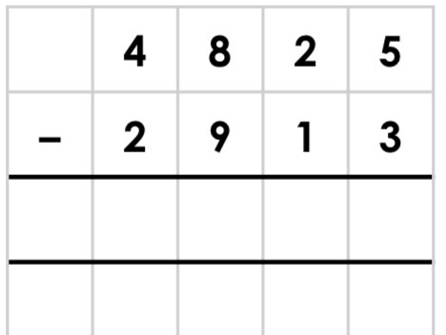

Answers

1) 5022
2) 4124
3) 4082
4) 1973
5) B
6) C
7) 3345
8) 1912

