Music

<https://www.bbc.co.uk/bitesize/topics/zcbkcj6/articles/z2mqw6f> - Use this link to learn about pulse and rhythm in music, these are two very important things to think about when learning music.

<https://www.youtube.com/watch?v=8myYyMg1fFE> – Use this link to listen to the sounds of the rainforest. What can you hear? List the different things you can hear, listen carefully. Can you hear the music in the sounds?

PHSE

Sea turtles are losing their habitat because of more tourists taking over the beaches. Sea turtles don’t have as many nesting sites anymore as humans are destroying them. Sea turtles regularly swallow micro-plastics (tiny bits of plastic) and they get stuck in their digestive system. Baby turtles also get stuck in little plastic circles used to hold cans together.

Imagine you are a sea turtle who can write and communicate with humans (crazy, I know). Your task is to write a short letter to the human civilization to explain how you feel and what is happening to sea turtles everywhere. Try to think from a sea turtle’s point of view, try to empathise with them.

Art/DT

Create a poster to save the Amazon rainforest. Draw a picture of the Amazon, you could google pictures of it and pick one to try and copy or make one up yourself. Research the kind of animals you find in the Amazon and include them in your picture. Your poster needs a big heading e.g. Save the Amazon or Stop Deforestation. You should also include some facts about deforestation, you can research these yourself. This link might help: <https://ypte.org.uk/factsheets/environment/rainforests-deforestation>

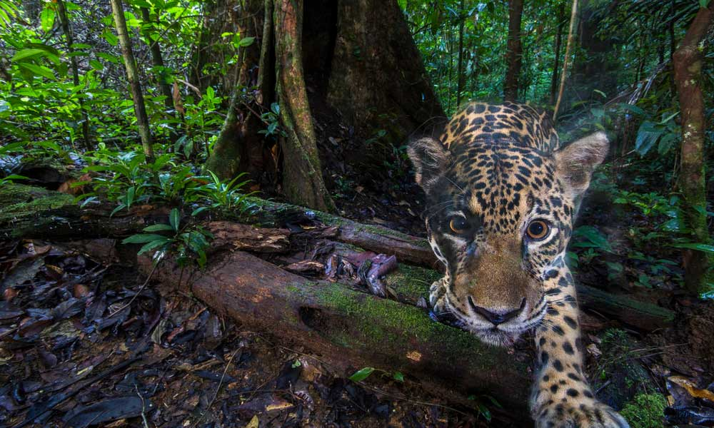

Activities WB 29.6.2020/6.7.2020

Our theme for the next fortnight is ‘Save Our Wonderful World.’

Work through it at your own pace.

Geography

See the Sea Pollution factsheet on the website. Feel free to read it all but I would like you to scroll down and read the section titled Plastic Pollution. I don’t want you to do any writing for this, I just want you to read it and make a change in your life that could help. Stick to your change, there are loads of small changes you could make which have a huge impact on plastic pollution e.g. stop buying plastic toothbrushes, you can get a bamboo Colgate brush in most supermarkets, use shampoo and soap bars rather than plastic bottles etc. Email me to let me know what change you make.

ICT

A big problem we have right now is the continued increase of greenhouse gas production. Greenhouse gases destroy the o-zone layer that protects our planet. Research where greenhouse gases come from and type up some facts about them e.g. one of the main greenhouse gases is CO2 (carbon dioxide).

P.E.

<https://www.youtube.com/watch?v=RJkkK3PG3qw> – Watch this video to see some modern day Native American culture, included in the video is part of a rain dance, the Native Americans really connected with and worshipped nature. Make up your own rain dance in a similar style to the Native Americans, let me know if your rain dance works!

Reading

<https://www.oxfordowl.co.uk/api/digital_books/1257.html> - Read Exploring the Deep, all about our oceans. Our oceans are heavily affected by climate change so this links in with our topic for this week.

Science

See the endangered animal factsheet. Pick one of the animals from the list that is on the endangered list. Use the information on the factsheet and your own research to create a non-chronological report about the animal. As well as the usual things such as habitat, diet, lifecycle etc. I want you to include why it is endangered and what we could do to help this animal. Remember your title and subheadings.

History

American president, Theodore Roosevelt, did a lot of work for the conservation of animals. In fact there is a national park named after him in North Dakota. Think about some of the animals that are endangered today, pick one that you would like to be protected. Find out as much as you can about your animal, where is its habitat, why is it endangered? etc. Make a poster or leaflet or powerpoint to help protect the animal you have picked, include images and information about the animal.