

Peanut butter and fruit sushi

* 4 slices of whole wheat bread
* ½ cup of peanut butter
* 1 apple, sliced into 1/4-inch strips
* ¼ cup raisins
* Juice of 1/2 lemon

***How To:***

1. Toss the apple strips with lemon juice and leave it aside.
2. Flatten the slices of bread using a rolling pin.
3. Cover the sushi mat with a plastic wrap.
4. Spread peanut butter on each slice of bread and add the desired fillings on one corner.
5. Roll the slices carefully, tucking the ingredients. Slice into 5 to 6 pieces and serve this easy sushi recipes for kids.

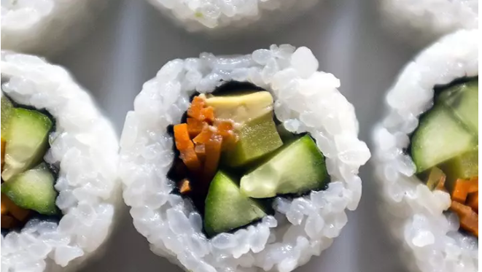

Carrot and avocado sushi

* 1 ½ tablespoon of sushi rice
* 2 tablespoon rice wine vinegar
* 1 tablespoon caster sugar
* 2 tablespoons of mayonnaise
* 4 nori sheets
* 1 avocado, thinly sliced
* 1 medium-sized carrot, grated

***How To:***

1. Place vinegar and sugar in a microwave-safe bowl and microwave on high for 30 seconds. Stir well to dissolve the sugar.
2. Transfer the rice to a ceramic dish and add vinegar to it.
3. Place a nori sheet shiny side down. Spread the rice over the nori sheet and two teaspoons of mayonnaise on the center of the rice.
4. Arrange carrot, avocado and carrot over the mayonnaise. Roll up firmly, cut into pieces and serve.

Sushi Recipe ideas.

* Fruit Sushi
* 3 tortilla rolls
* 1 cup mango, chopped
* 1 peach, cut into pieces
* 1 apple, cut into pieces
* 3 tablespoons of powdered sugar
* 6 tablespoons of cream cheese
* 1 teaspoon of vanilla extract

***How To:***

1. In a mixing bowl, combine powdered sugar, vanilla and cream cheese.
2. Spread the cream cheese over the tortilla rolls.
3. Line a side of the tortillas with the chopped fruit.
4. Roll it up tightly and then cut it into pieces. The fruit sushi for kids is ready.

Baby Sushi

* 200 grams of sushi rice
* 375ml of cups water
* 3 tablespoons of rice wine vinegar
* 1 teaspoon of sugar
* 6 nori sheets
* Bamboo mat
* Carrot sticks
* Cucumber sticks
* Cooked chicken
* Avocado slices

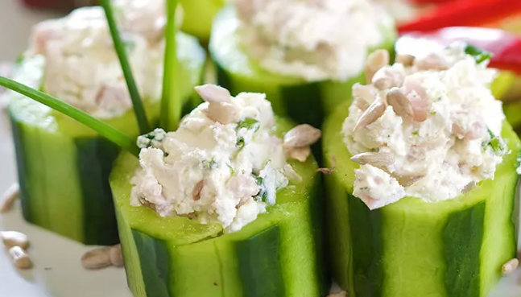

Veggie Sushi

* 1 English cucumber
* 1 carrot, peeled and shredded
* ¼ cup of raisins
* ½ cup of cream cheese
* Chives

***How To:***

1. Slice 8 long slices of cucumber using a peeler.
2. Place a small amount of carrot at the end of the cucumber slice.
3. Add a spoon of cream cheese and press raisins into it.
4. Roll up the cucumber carefully and secure with a chive.