Religious Education
Year: 4 Teacher: Mrs Smith Week Beginning: 8th June 2020
Our RE topic for this half term focuses on Belonging, Confirmation is a celebration of God’s gift of friendship with Jesus and with the parish community. There are seven Sacraments which celebrate special events in our lives. Through the Sacraments, the Holy Spirit helps us to grow closer to God in love.

Read the information about the Sacrament of Confirmation on the next pages or watch the video https://www.youtube.com/watch?v=sFo-9H-lZlk
If you have older family members who have been confirmed, try asking them for more information or to answer questions you might have.
Questions to discuss:

*What does the bishop actually do? To whom does the bishop pray? What special action does he make with his hands?
*Why do you think the candidates have sponsors? What do they do? Whom do they represent?
*What do you think the promises mean for the life of the candidates?
*What is the significance of the anointing?
*What gift do the candidates receive at Confirmation and how do you think these help them in their lives?
Your task is to use the words of the prayer to the Holy Spirit, to design a prayer card that could be given as a memento for someone who has received the Sacrament of Confirmation. Use the template below or design your own.
Don’t forget to email me your card when you have finished – k.smith201@durhamlearning.net

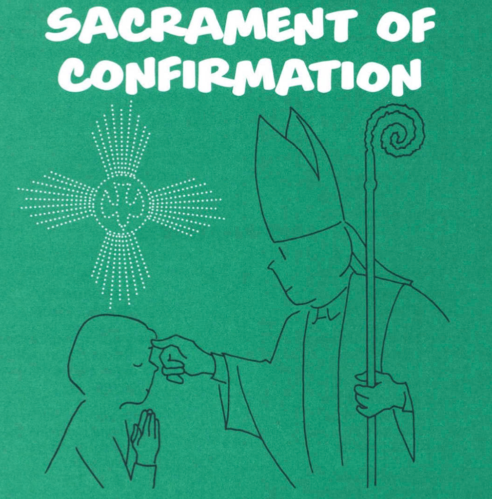

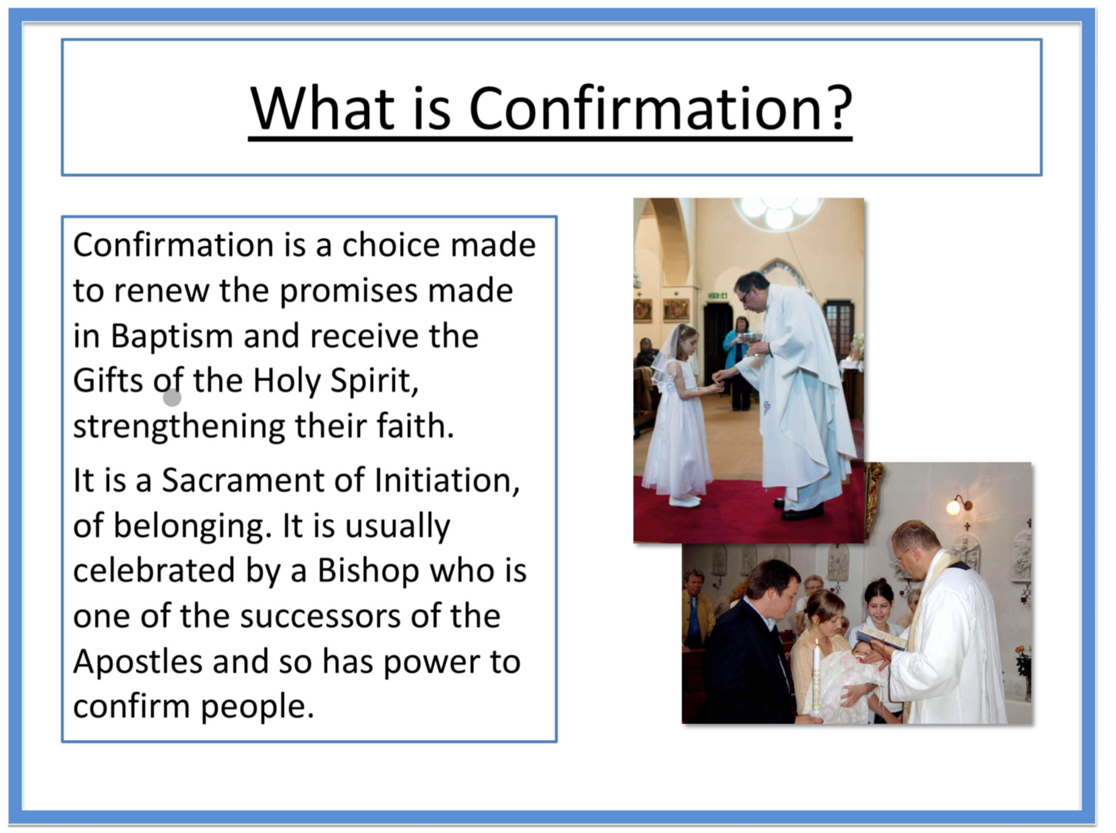
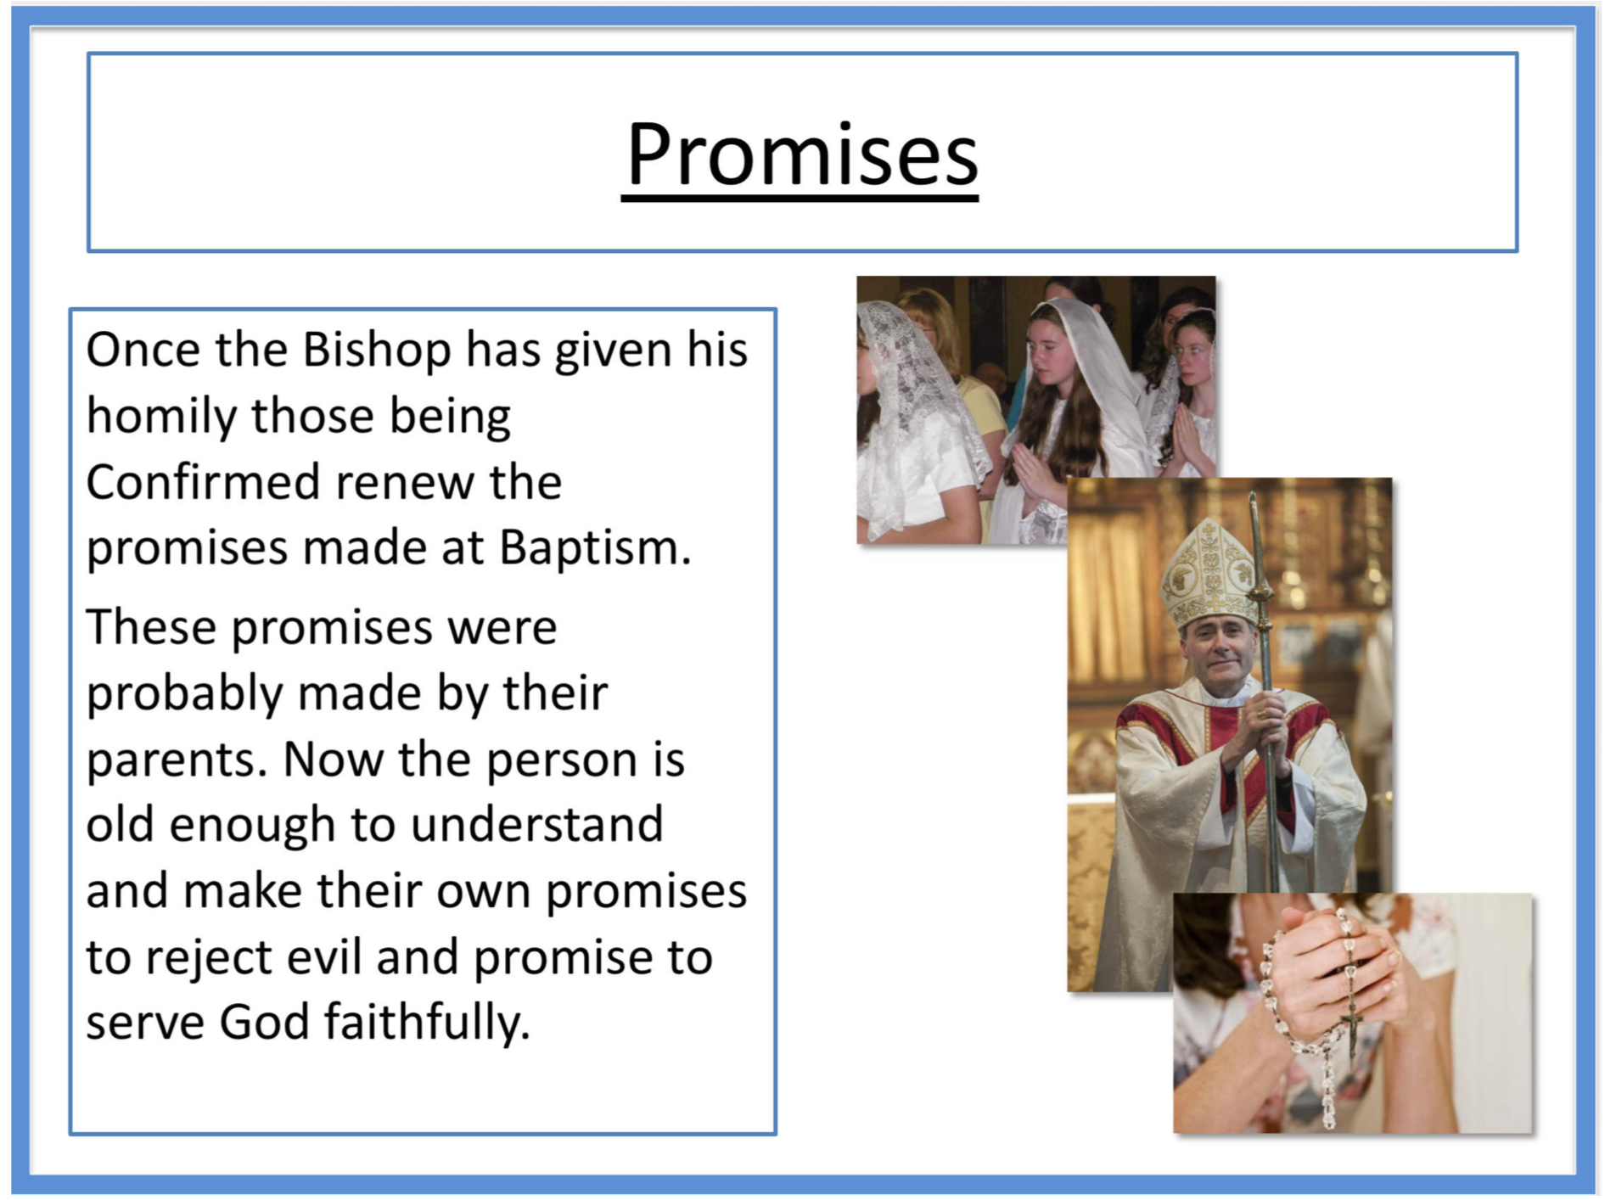
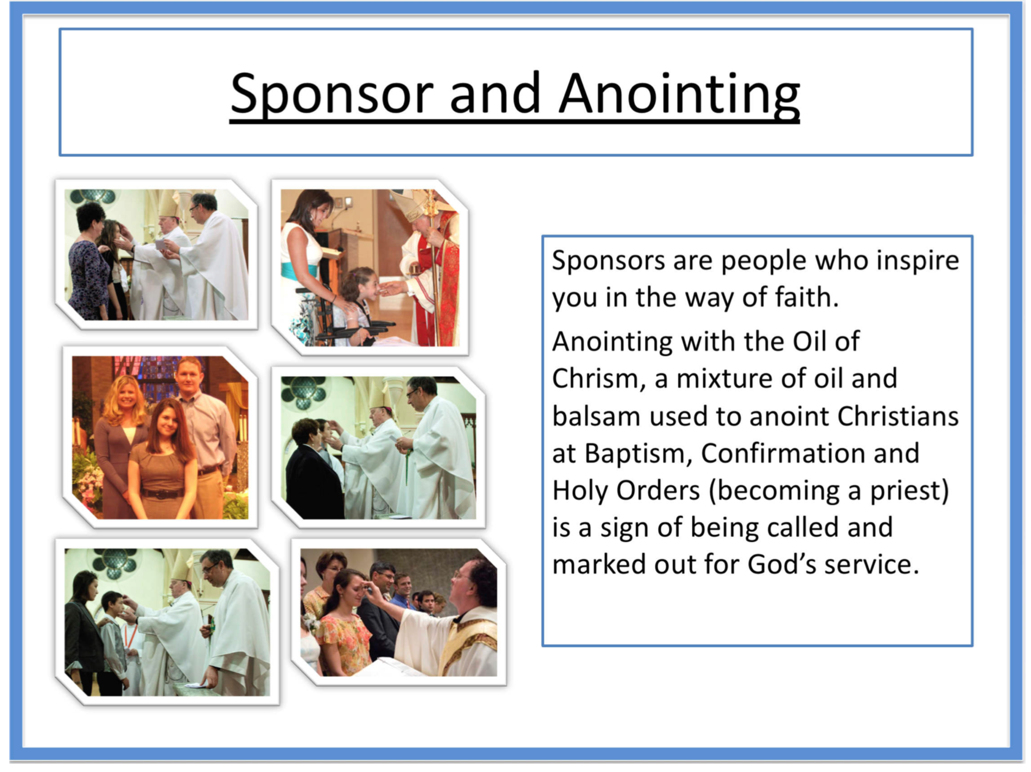

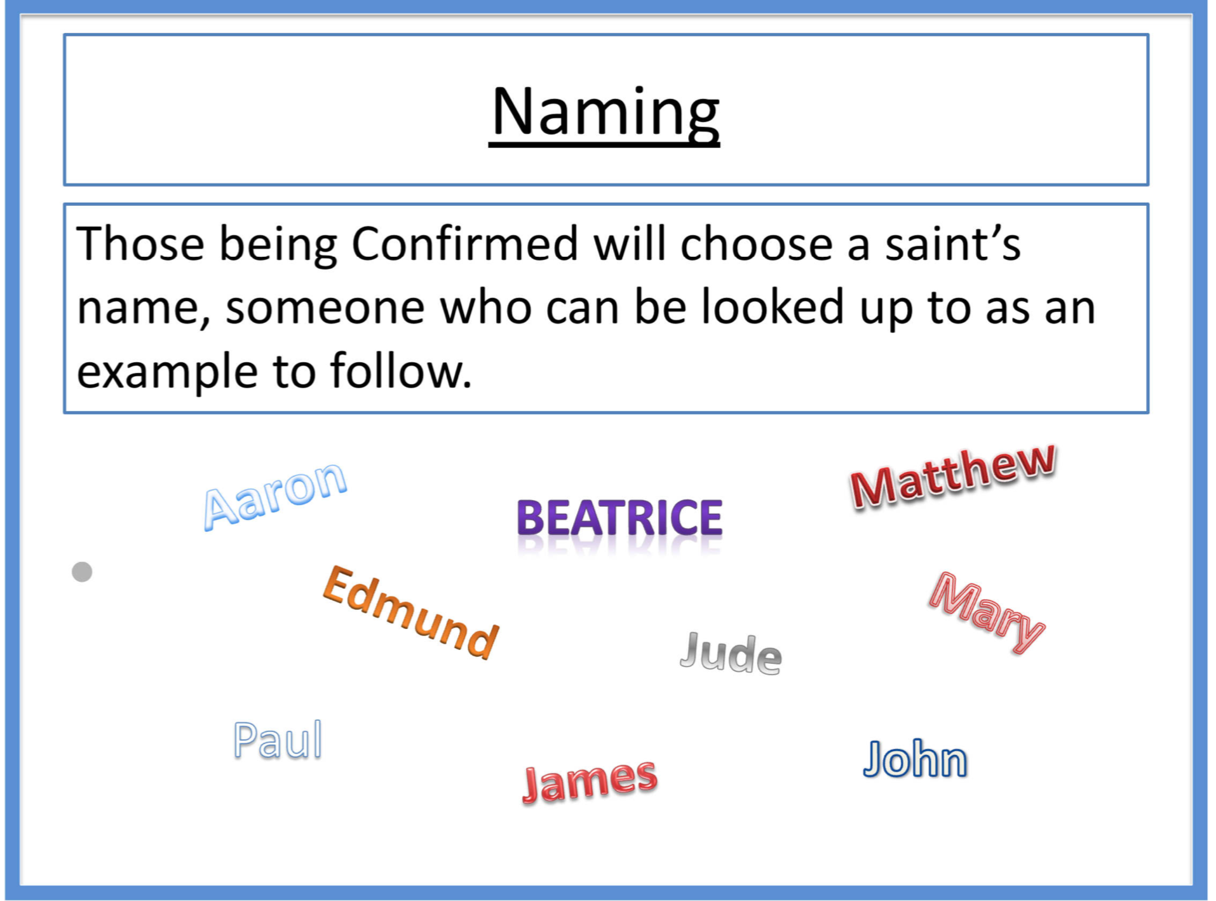
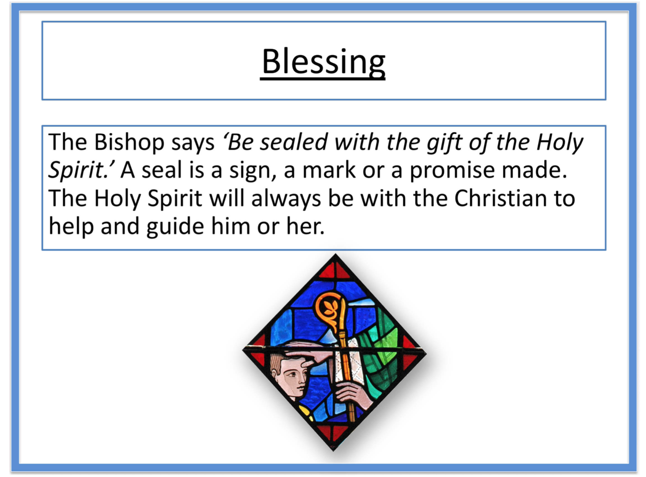
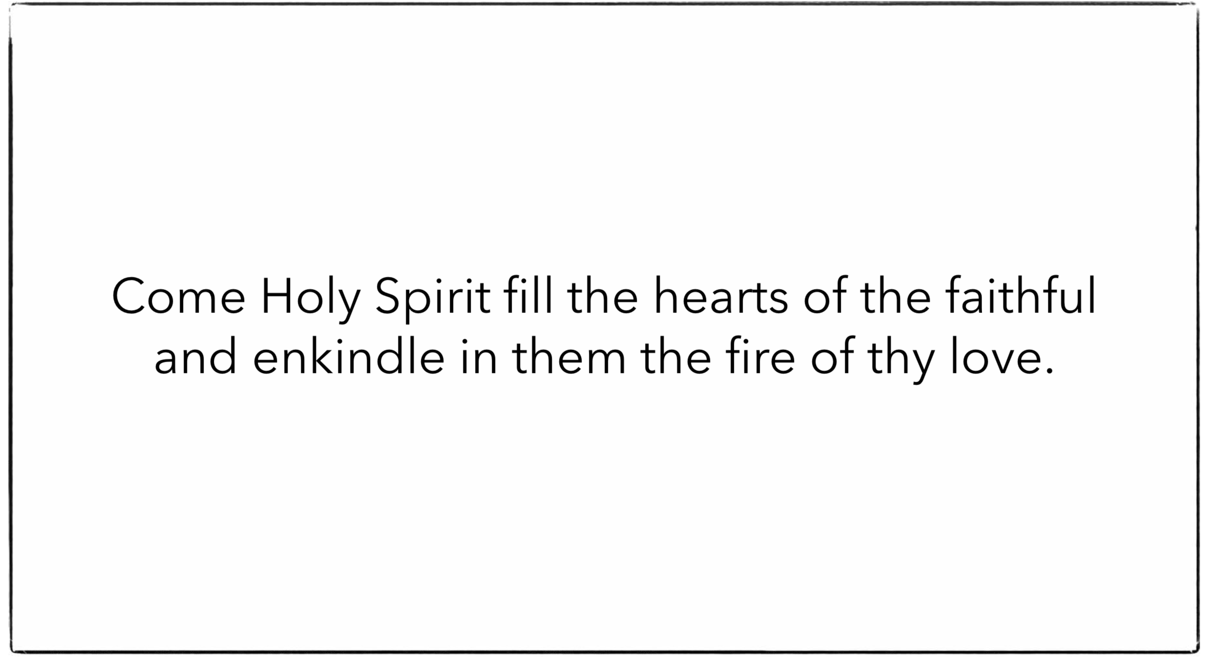

Prayer Card Template

