Religious Education

Year: 4 Teacher: Mrs Smith Week Beginning: 22nd June 2020
This week, you will be learning about the life and work of Sean Devereux. Sean was a missionary and aid worker who died in Kismayo, Somalia in 1993 while working with UNICEF to aid children in need. He has since become an important role model for the aid- working vocation, particularly among Christians.
Read about Sean’s life on the following page and discuss the questions with an adult.
Questions to discuss:
- Read 1 Corinthians on the next page. What do you think is the link between the reading the life of Sean Devereux?
- How do you think Sean witnessed to the call to be a Christian?
- Why do you think his life is celebrated? Q
- Where is Somalia?
- What impressed you most about Sean?
- Why do you think he stayed there, even though he knew the dangers?
- In what ways did he live out his Confirmation?
- Do you think everyone is called to do the same sort of things as he did?

This week, your task is to

Don’t forget to email me your prayer when you have finished – k.smith201@durhamlearning.net

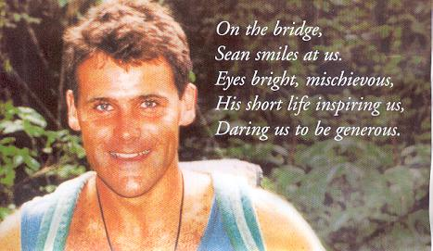
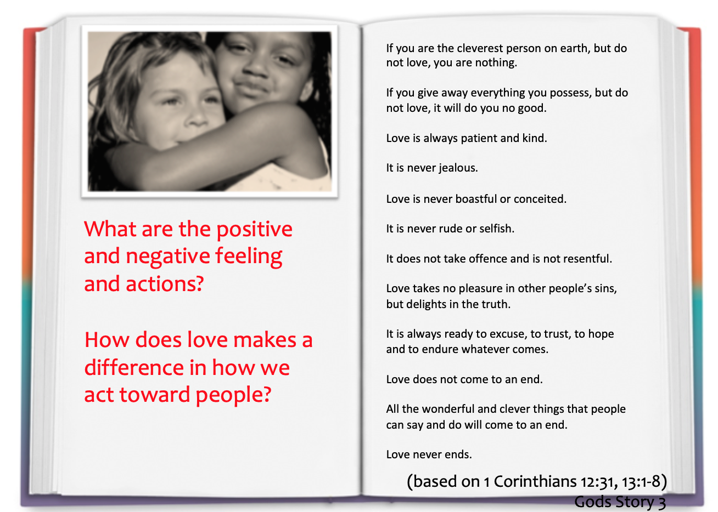

Sean Devereux
- Sean Devereux was a teacher of PE at the Salesian School in Chertsey, Surrey, where he worked for two years before he received his calling to work as a missionary in Africa and help those in need.
- He arrived in Liberia in February of 1989 and began working at St. Francis School in Tappita District. Sean worked tirelessly to protect the young people he was working with but unfortunately he soon found himself imprisoned by the local government after pleading for the release of a student drafted into the army as a child-soldier.
- After being release from prison Sean carried on the work he had started, however escalating violence during the country’s Civil War forced the closing of the school and so Sean joined the UN refugee program.
- On one occasion working with the UN, Sean was beaten by soldiers after confronting one of them for attempting to steal food meant for refugees. Ultimately he was ordered out of the country in September 1992. Sean left the UN and travelled to Sierra Leone where he stayed until he started working with UNICEF.
- Sean left Sierra Leone and began working with UNICEF in Somalia. In Somalia Sean was assigned to organise relief for the starving, particularly children, in Kismayo.
- Kismayo was under the rule of one of many warlords in the country. Sean’s work helping the needy and starving put him at odds with the warlord and his regime.
- After only four months in Somalia, Sean was assassinated by a lone hired gunman while walking near the UNICEF compound on Saturday, 2 January 1993. His assassination came on the eve of the visit from UN Secretary General Boutros Boutros-Ghali. Sean died spreading the Good News and aiding children in need.

