Art/DT

Frida Kahlo was born and lived her life in Mexico, North America. Learn more about her here: <https://kids.kiddle.co/Frida_Kahlo>

As well as being an amazing artist with a lifelong disability Frida fought for Women’s rights also. Her most common work was painting self-portraits of herself to show how she was feeling. I would like you to think about you’re feeling and draw or paint a self-portrait to reflect your feelings. You could even add some kind of animal in the background or on our shoulder like Frida did with the monkeys.

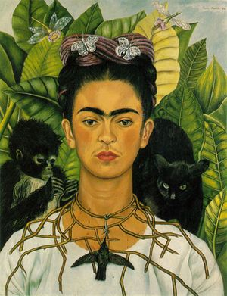

Music

<https://www.youtube.com/watch?v=Z0WhZ_leBMM&list=PLQnfyusNmPmsW_0_JO18fNRnqxMVmtoAH&index=11> - Have a listen to some of the songs on this playlist, I’m sure you will recognise one or two. This is steel pan music, famous throughout the Caribbean but particularly in Trinidad and Tobago, the second most southerly country in North America. Which song would you like to hear played on steel drums? Steel drum music originated by using empty metal containers lying around. If the adults in your house agree why not give it a go yourself? Play a tune using what you can find.

PHSE

Rosa Parks, Martin Luther King, Bob Marley, Frida Kahlo, Malcolm X, Nellie McClung, Huberte Gautreau, Barack Obama, Cesar Chavez and many more people lived, fought and even died to make life better for other people. They dedicated their whole lives to their cause. I’m not asking you to do that but I am asking; what could you do to improve the life of somebody else? You don’t have to change the entire world but maybe just brighten somebody’s day. Plan it, write down what you are going to do. Do it, complete your kind action. Review it, write down how it went, how did the person feel, how did you feel?

Geography

There are 23 countries in the continent of North America. Take your time to draw a map of North America with country boarders then label each country. For extra points can you draw the states of the USA on your map?

Activities WB 15.6.2020/22.6.2020

Our theme for the next fortnight is ‘Our Wonderful World.’

Work through it at your own pace.

We will be focussing on the continent of 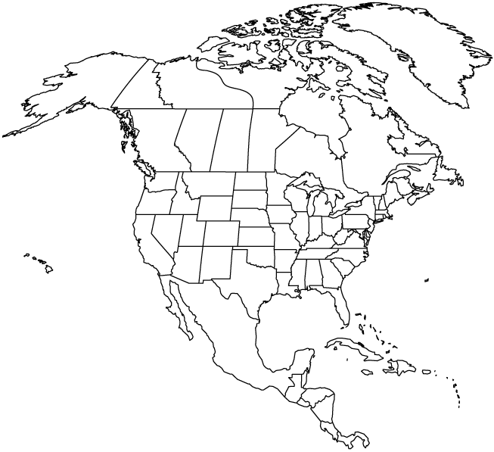North America.

P.E.

The most popular sport in North America is basketball. If you have a ball (it doesn’t have to be a basketball) you could practise some chest and bounce passes with someone from your household. Don’t forget to keep active! It doesn’t matter what you do, it’s your choice but you should raise your heart rate for at least 30mins every day. Join in with Joe Wicks, practise your favourite sport, join in a virtual exercise class or make your own.

Reading

<https://www.oxfordowl.co.uk/api/interactives/30572.html> - Read Space Scientist, the story of an unexpected space scientist.

Science

Research a typical diet for a person living in the Caribbean and compare it to what your regular diet would look like. Write both diets down in your book and then below write a few sentences to explain which diet you think is healthier and why. Remember to be honest about your diet, don’t miss out the sweets and chocolate! If you’re struggling to find much information on a Caribbean diet then use the June 15th Resources to help you.

ICT

Pick one of the 23 countries in North America (except the USA) to research. Make a fact file on your country either in your book or on a computer. Try to find out about the culture in your country, the religions people follow, the food and music they like and how they like to socialise.

History

Martin Luther King was born and lived in the USA. Find out more about him here: <https://www.natgeokids.com/uk/discover/history/general-history/martin-luther-king-facts/>

His ‘I had a dream…’ speech is very famous and inspired people to make better choices to improve the world. Your task is to write your own I have a dream speech. Write about all the things you dream could be better in the world e.g. I have a dream that one day nobody will litter and we will recycle all of our rubbish. Etc. It doesn’t need to be long but think carefully about what you would like to improve.