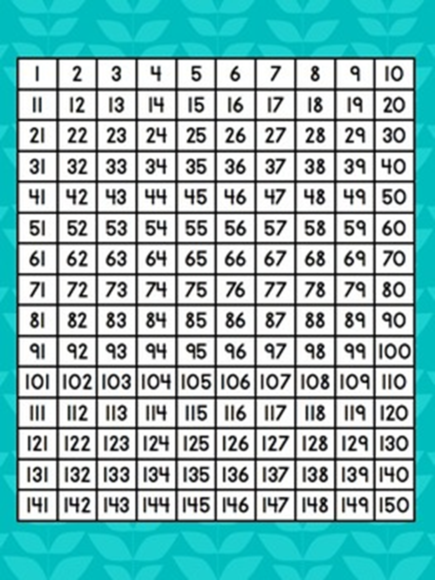Tuesday 30th June

Wednesday 1st July

Friday 3rd July

1. List all the multiples of 5 and 7 up to 154. Circle the common multiples.
2. Find the lowest common multiple (LCM) of 6 and 8.
3. Find the lowest common multiple (LCM) of 7 and 9.
4. Find the lowest common multiple (LCM) of 12 and 8.
5. Draw a Venn diagram with 3 circles. In one circle write all the multiples of 3, in the next write the multiples of 4 and in the third write the multiples of 5. In the crossover sections you need to write the common multiples and the middle section write the common multiples of all 3.

12

?

20

8

4

6

3

15

10

5

5

4

3