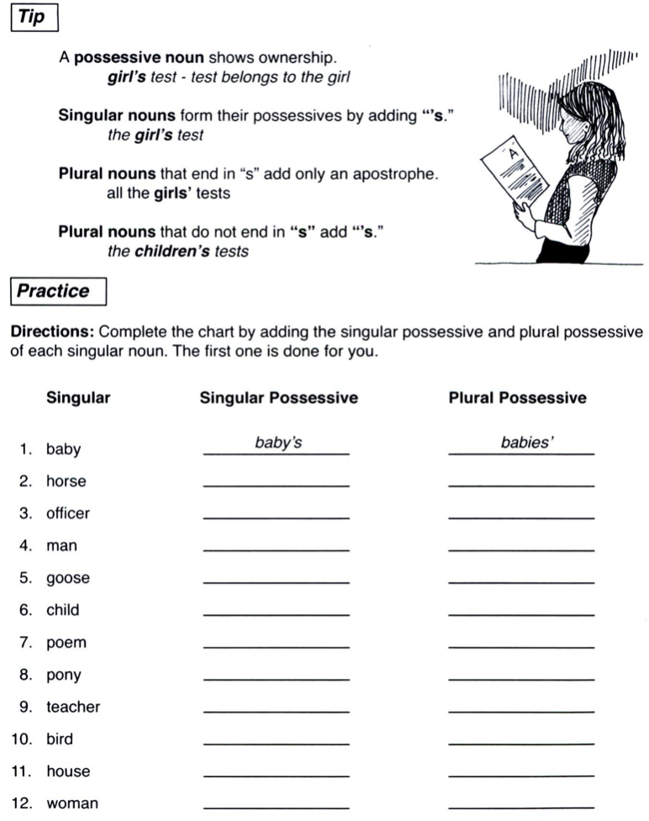

Challenge – Look at pages 25, 28 and 52 (the blurb). Can you find up to three examples of singular and up to three examples of plural possession from the reading book, Comic Capers? Record them on the grid below.
