Grammar activity
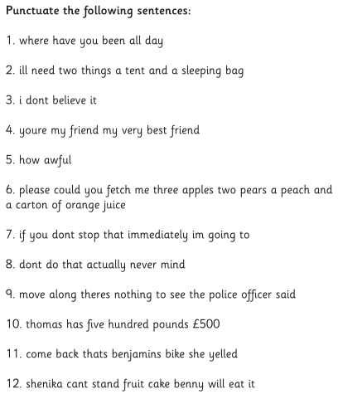

Comprehension Activity
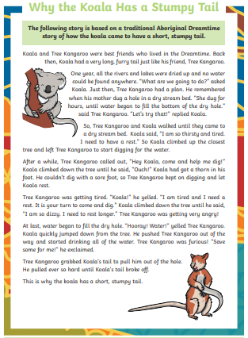

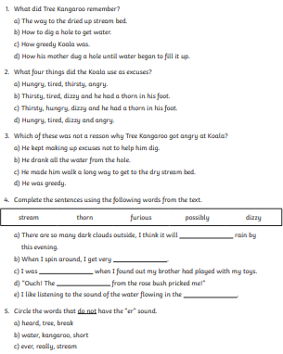
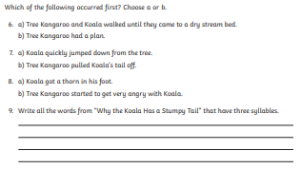

For our comprehension this week you have read “Why the koala has a stumpy tail”, a traditional aboriginal folk tale to explain an animal’s appearance. I would like you to write your own version of the story to explain why an animal looks the way it does. Remember that this isn’t a science job – you aren’t explaining evolution! I want you to be inventive and creative with your writing. I have put some suggestions for animals below but you can come up with your own if you’d like!
- Why the giraffe has a long neck
- Why the kangaroo has big feet
- Why the elephant has a long trunk
- Why the snake has no legs
- Why the lion has a mane
- Why the tortoise has a shell
In the resource area I have wrote my own version called “Why the deer has antlers” if you would like to magpie ideas!

Once upon a time, there were two animals walking through a large, leafy forest. One animals was a young, impatient deer and the other was a wise old rabbit. They were very hungry: There was a stream to drink from but there was no grass on the ground to eat. They had been lost for what seemed like forever and were becoming desperate.
They had nearly lost all hope when a miracle happened. “Look up there!” said Rabbit excitedly. Deer looked up and his mouth started to water – it was a fruit tree! All of the fruit looked delicious and there was so much of it on the branches. “We’ll have to climb up the tree to get some!” said Deer hungrily.
“We cannot climb trees – we do not have hands like a man or a monkey to grip onto the trunk and branches,” said Rabbit sadly.
“Well I am starving! We can’t give up now – that fruit is so close I can almost taste it!” responded Deer angrily.
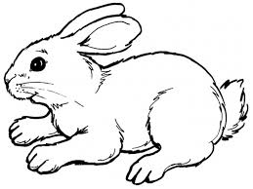
Rabbit sat back and studied the tree and the fruit. Rabbit was very wise and recognised the fruit. He knew what was going to happen to the fruit. “I have eaten this fruit from the ground before when it was bright yellow. The fruit on the tree is almost all yellow. One more day in the sun and it will turn bright yellow and fall from the tree. When it drops tomorrow morning there will be plenty for both of us,” Rabbit told Deer “We can sleep here tonight and tomorrow the fruit will fall for us both,”.
Deer agreed with Rabbit and they spent the day sitting by the tree. As it became dark Rabbit curled up and went to sleep. Deer was not happy. He was young and impatient and he was hungry now! He was also very greedy and did not want to share with Rabbit. “If I can knock the fruit down now I can eat my fill before Rabbit even knows about it,” Deer said greedily to himself.
Deer tried and tried and tried but he could not climb the tree. He even tried to pull himself up the tree with his mouth and it did not work. “The old Rabbit was right, Deer cannot climb trees,” Deer said angrily to himself. He did notice that the fruit was wobbling on the branches as he moved the tree whilst trying to climb it. “Rabbit said the fruit was ready to fall, and it looks very heavy. If I hit the tree hard enough it will all fall down,” Deer thought, feeling a bit smug at how clever he was being.
Deer took several steps back and ran into the tree. The fruit wobbled but non fell down to the ground. He took a longer run up and the whole tree moved, but still no fruit fell down. Deer took the longest run up he could and ran as fast as his four legs would carry him. BBOOOOOMMMM! He crashed into the tree. He tried to step backwards to check the ground for fruit. He could not move! His head was stuck on the branches! Deer panicked and pulled and pulled and pulled. He managed to get his head free but two large branches were stuck to his head! He threw his head backwards and forwards but the branches were stuck fast. In a panic, Deer ran away from the fruit tree.
To this day, deer have branch-like antlers on their heads. Meanwhile the wise Rabbit woke up the next morning and, as he predicted, the fruit began to fall and he had plenty to eat. In the case of Rabbit, good things come to those who wait!

