Religious Education
Year: 5 Teacher: Mr McPhail Week Beginning: 8th June 2020

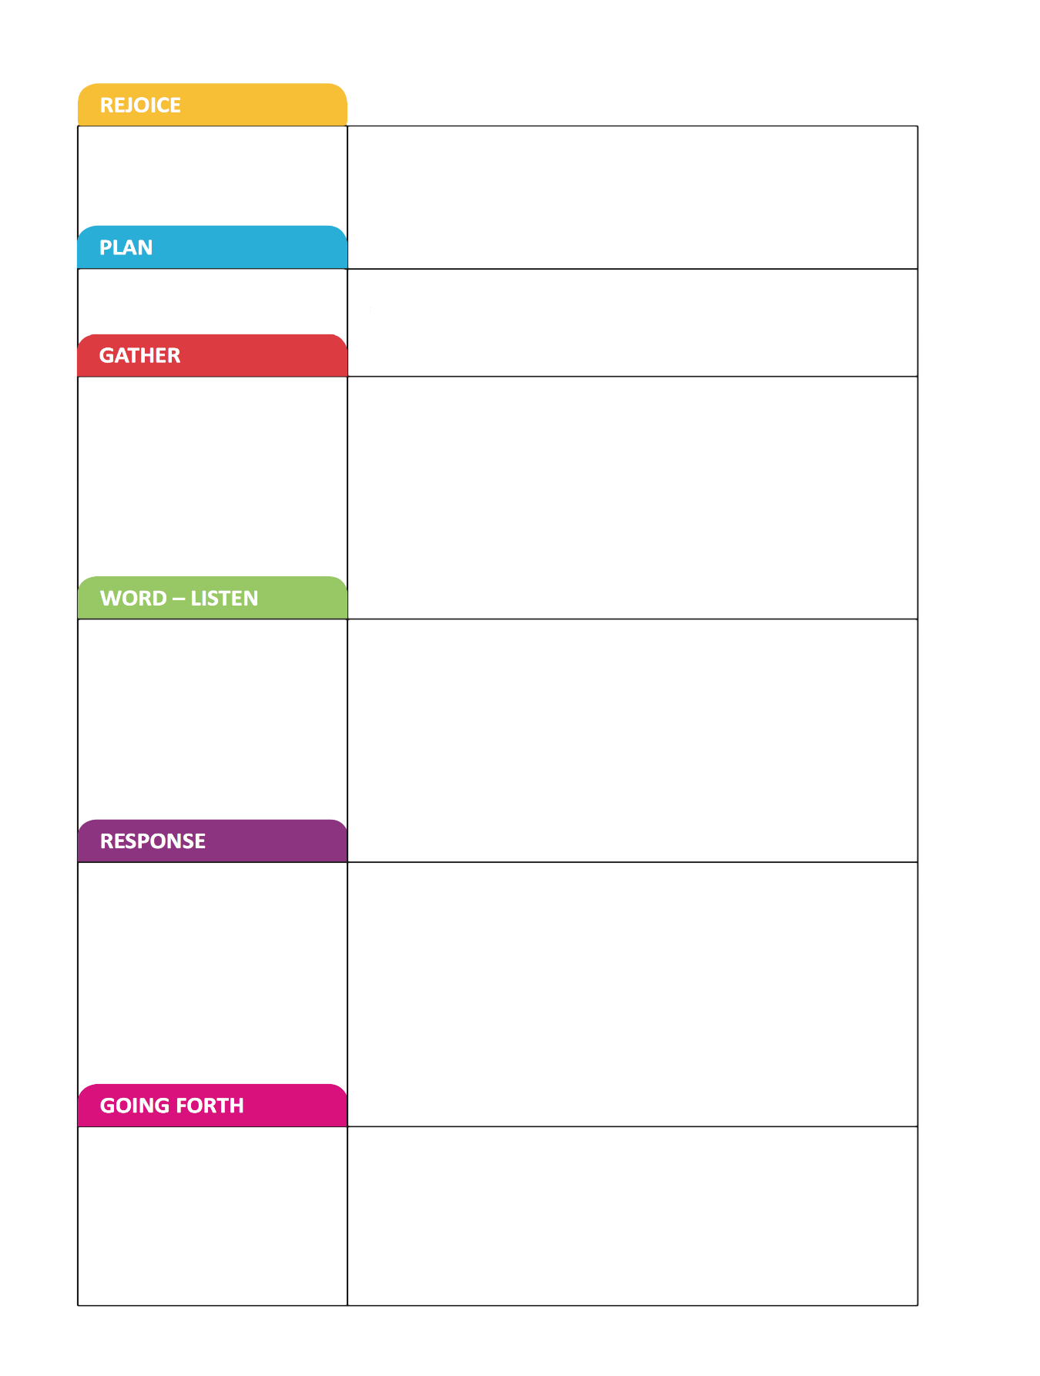
I would like you to plan a simple liturgy to celebrate Pentecost. You may want to celebrate your liturgy with the people in your house.
Use what you have remembered and your
reflections to help to plan our class celebration of this topic .

Pentecost
I want to include
How will we gather?
Why?
Which scripture from the topic would you like to use?
Why?
What action, prayer response would you like to include?
Why?
How will we end and carry the message to others in some way?
Why?

