Religious Education
Year: 5 Teacher: Mr McPhail Week Beginning: 29th June 2020

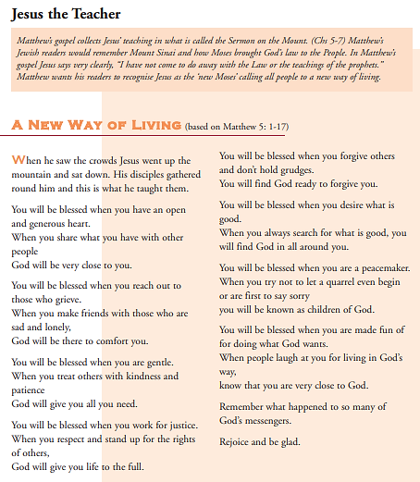
- Which Beatitude do you like best and why?
- In what way are the Beatitudes different from the Ten Commandments?
- How does Jesus want us to live?
- How will we be rewarded for living in this way?

I would like you to write your own modern version of the beatitudes reflecting on modern life. I would like you to write at least 5 modern beatitudes. Can you create a picture to show each modern beatitude in action?

