Religious Education
Year: Class 3 Teacher: Miss Brack Week Beginning: 22nd June 2020

Our RE topic for this half term focuses on choices and understand it is important to examine our conscience in order to make a good choice and minimise bad effects for ourselves and others.
This week I would like you to think about how we can say sorry to God during the Sacrament of Reconciliation.

Task: One of the more formal ways of saying sorry to God is through the Sacrament of Reconciliation. It is sometimes called Confession or Penance. It is in this Sacrament that Christians celebrate God’s love and mercy. It helps them to think about their lives and how they are following Jesus and it gives them the opportunity to make a new start.
The person will pray an act of sorrow such as:
O my God because you are so good,
I am very sorry that I have sinned against you
and with the help of your grace I will not sin again. Amen

Create your own act of sorrow prayer card and decorate it.
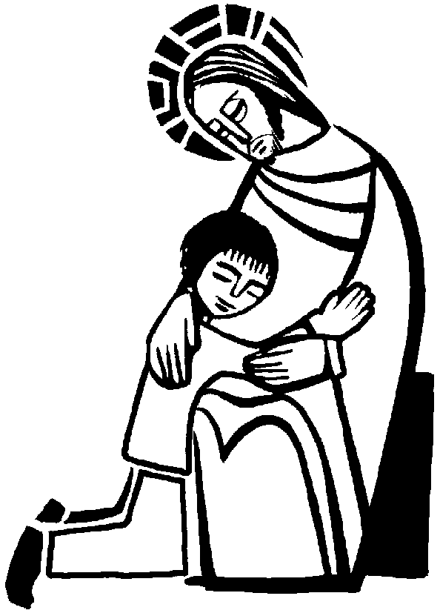

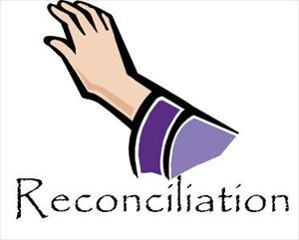
Don’t forget to email me your fantastic work when you have finished as I’d love to see it! j.brack300@durhamlearning.net

