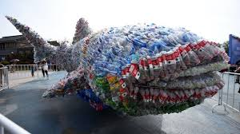.

PE

Have a go at the following these Tai Chi exercises – the movements are very relaxing and are based on nature and the environment around us!

<https://www.youtube.com/watch?v=alCP5R3EFxA>

Drowning Prevention and Water Safety

It is always important to be careful and behave sensibly around water. Read the information in the resources section and create a poster to explain how to be sensible and safe around water!

PHSE

Why is it important to look after the environment? Whose job is it to look after the environment?

Can you write about what the following groups can do to stop plastic pollution?

1. Ordinary people
2. People who run factories
3. World leaders

Art/DT

Create an animal! You can use recyclable materials or maybe natural materials (sticks, stones etc).

Can you create a natural landscape? You may use whatever medium you wish (see the resources for examples).

Create a sketch of an animal of your choice! You can find a picture on the internet or draw from real life!

Music

Listen to the below tracks and write how the pieces make you feel. Create word clouds to show what you can hear and how the sounds make you feel!

<https://www.youtube.com/watch?v=QE_jOCqKE3w>

<https://www.youtube.com/watch?v=fvRkWO5g2HE>

<https://www.youtube.com/watch?v=vPhg6sc1Mk4>

Geography

Research one of the climate zones in the video clip and write about what the climate zone is like! Can you compare it to another climate zone?

<https://www.bbc.co.uk/bitesize/clips/zr7hyrd>

Activities WB 29.6.2020 / 6.9.2020

Our theme for the next fortnight is the environment and animals.

Work through it at your own pace.

We will be focussing on the environments and animals from across the world!

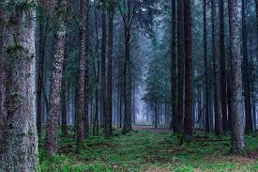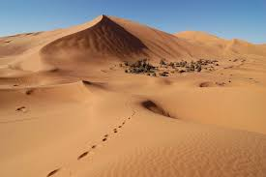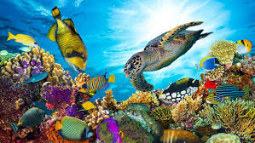

History

One of the most important animal researchers ever is a woman called Jane Goodall. Create a fact file about her and her important work!

<https://kids.kiddle.co/Jane_Goodall>

Science

Watch the below cartoon about the journey of a plastic bottle and create a cartoon strip to illustrate it! <https://www.youtube.com/watch?v=erGnf7ws20E>

Research the meaning behind the symbols (see 29.6.2020 – Resources) and track how many you can find at home!

Reading

. Please see the link for “Rainforest Calling” to access the reading book for this topic!



ICT

Create a Powerpoint about an animal of your choice! I want to know key facts about it, where it lives and anything else that is interesting about it!

