**Art**

Look at Aboriginal art and create your own art work in the same style.

<https://www.youtube.com/watch?v=tXxuOF0qMss>

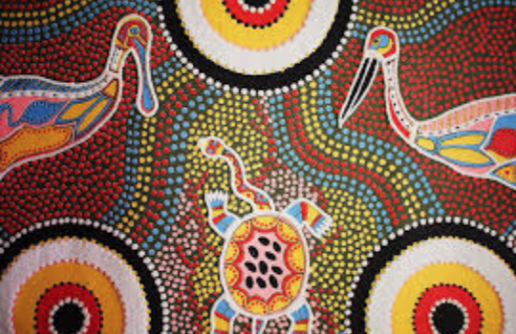

**Music / DT**

Learn about the Australian Didgeridoo

<https://www.bbc.co.uk/bitesize/clips/z92yr82>

Make your own didgeridoo, using tubes, rolled up paper or card. Decorate it using traditional Aboriginal art. Then practise playing. Make up your own dance.

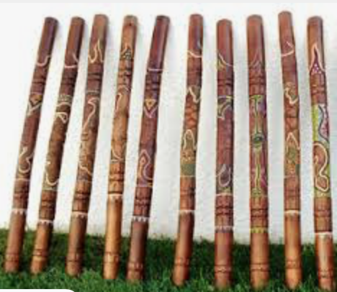

**Geography**

Create an advertisement to encourage people to visit Australia.

You could think about

* the weather
* the wildlife
* famous landmarks
* coastline
* things to do

**PE**

Watch the All Blacks perform their traditional Aboriginal dance, the Haka.

<https://www.youtube.com/watch?v=Xkg3NQjDwTI>

Learn how to do it yourself.

<https://www.youtube.com/watch?v=id-Bvcc6YbQ>

.

**PHSE**

Learn about equality and diversity from the file pshe 15.06.2020

Write an acrostic poem using the word diversity about what this is and why we should celebrate it.

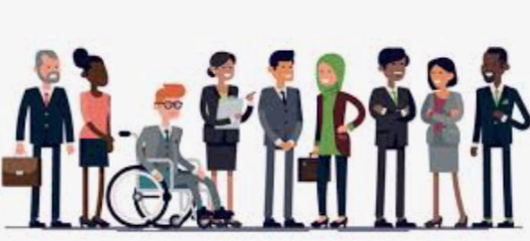

**Drowning Prevention Week**

**F**ind out about the dangers of water and how to keep yourself safe

https://www.youtube.com/watch?v=bZ78zGQTwUA

[**https://www.rospa.com/leisure-safety/Water/Advice/Children-Young-People**](https://www.rospa.com/leisure-safety/Water/Advice/Children-Young-People)

Design a poster to warn people to be safe around water.

**Science**

<https://www.bbc.co.uk/bitesize/topics/zx882hv/articles/z3c2xnb>

Create food chains for some animals from Australia (for example - Kookaburra, Tasmanian Devil, Dingo) wombat,

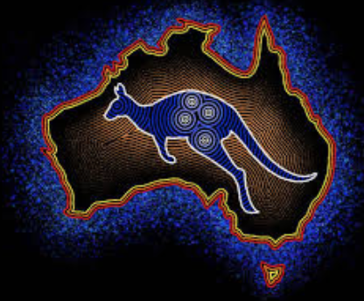

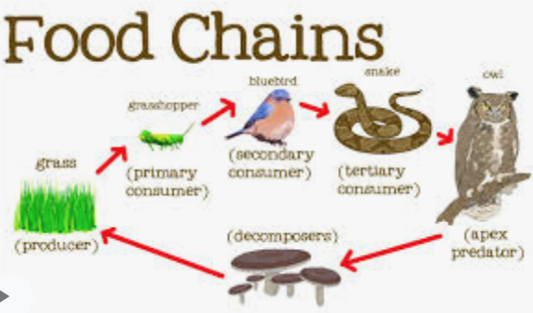

Activities WB 15.6.2020/ 22.6.2020

Our theme for the next fortnight is ‘Wonderful World’.

Work through it at your own pace.

We will be focussing on celebrating different cultures, looking specifically at the Aboriginal culture of Australia.

**Computing**

Develop your programming skills by completing challenges 1,2 and 3 to make the shapes shown.

<https://www.transum.org/software/Logo/>

Try challenge 4 if you feel confident.

**History**

<https://kids.britannica.com/kids/article/Australian-Aboriginal-peoples/629039>

<https://www.natgeokids.com/uk/discover/history/general-history/aboriginal-arts-and-culture/>

Learn about Indigenous Australian people. Compare their traditions and cultures with the people who live there today.