PE

The Haka is a traditional Maori dance. They were originally used before a battle to intimidate the enemy, welcome guests and mark important occasions. They are famously performed by the New Zealand rugby team (the All Blacks).

<https://www.youtube.com/watch?v=GyZEUeAoFKE>

The below clip is a video tutorial of how to perform a haka. Have a go at performing it – once you’ve learnt it could you teach it to someone else?

<https://www.youtube.com/watch?v=p5cHElD5cf8>

PHSE

Aboriginal Australians and Maori celebrate their culture and share it with other people in the world.

Write a piece to explain why you think it is important to learn about other cultures. You can also illustrate your work!

<https://www.bbc.co.uk/newsround/43710833>

Art/DT

Create an example of a Maori pattern (see resources for examples).

Aboriginal art often uses dots to build a larger picture. Can you create your own picture made up from dots of colour? (see resources for examples).

Aboriginal peoples would make “story stones”. They would draw onto them and then used them when they retold stories to jog their memories. Copy the symbols and create 3 of your own that could be used on story stones! (see resources for existing story stone images and template).

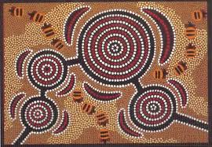

Music

Listen to the below tracks and write how the pieces make you feel. What do you think each piece would be used for? What might be used to make the sounds? Which do you prefer and why?

<https://www.youtube.com/watch?v=nN-542IYoE0>

<https://www.youtube.com/watch?v=hhfZ0hvrhmA>

You can also watch this interesting clip about how to make a didgeridoo from a tree in the traditional aboriginal way!

<https://www.bbc.co.uk/bitesize/clips/z92yr82>

Geography

Create a fact file about Australia or New Zealand!

If you could visit either New Zealand or Australia, which one would you go to or why?

Activities WB 15.6.2020 / 22.6.2020

Our theme for the next fortnight is ‘Wonderful World’

Work through it at your own pace.

We will be focussing on Oceania, particularly looking at Australia and New Zealand!

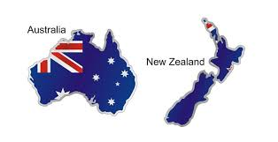

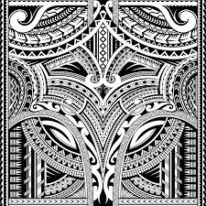

History

Write a report about the history, make-up and importance of Uluru.

<https://kids.kiddle.co/Uluru#:~:text=Uluru%20is%20sacred%20to%20the,a%20UNESCO%20World%20Heritage%20Site.>

Science

Australia has a very warm climate with little rainfall. New Zealand has a temperate climate with moderate rainfall (similar to the UK).

Design a plant or animal that could live in either Australia or New Zealand. You may want to look at their existing animals for inspiration!

Reading

I have put a selection of traditional Aboriginal and Maori tales in the Class 5 Resources for you to read over the next two weeks! Have fun learning about their cultures and traditional tales.

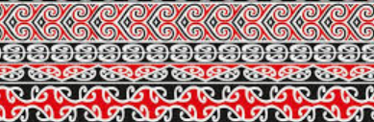

ICT

Imagine you are planning a trip to either Canberra (Australia) or Wellington (New Zealand). Research and make a PowerPoint of fun/interesting things you can do in that city!

