Activity 2 – Add two four-digit numbers

1. Complete the calculations below. What is the value of the circled digit?
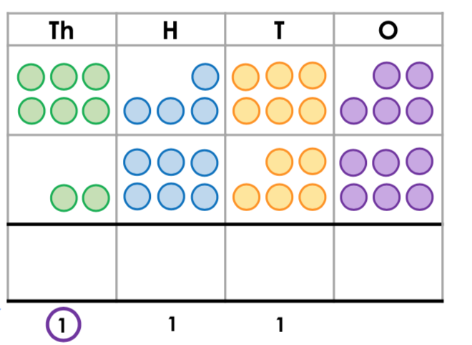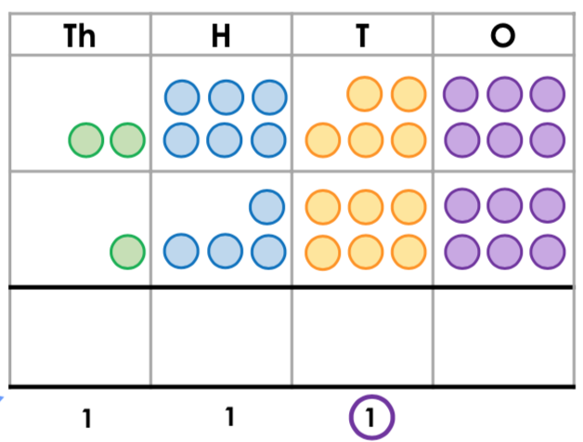
+
+

2. Find the missing numbers for each bar model.

3635 | 1465

2360 | 4857

3. Find the missing number for each part/whole model.
3619
5472
?
?

4718
1493

4. Use the partitioning method shown below to answer the next 5 questions.
. 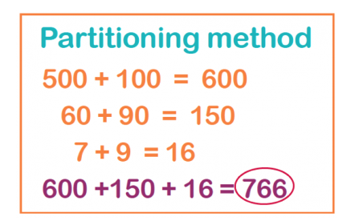
a) 3125 + 2572 = b) 5038 + 2791 =
c) 1759 + 2840 = c) 4527 + 2847 =
e) 7462 + 2783 =

