Religious Education
Year: One Teacher: Miss Jewitt Week Beginning: 11th May 2020

This week we are going to learn about a very special time in Jesus’ life called Pentecost.
This was when Jesus sent a VERY special helper to the disciples.
Enjoy listening to and watching this very special story from the Bible.
https://www.youtube.com/watch?v=IqG_lvZhU-A
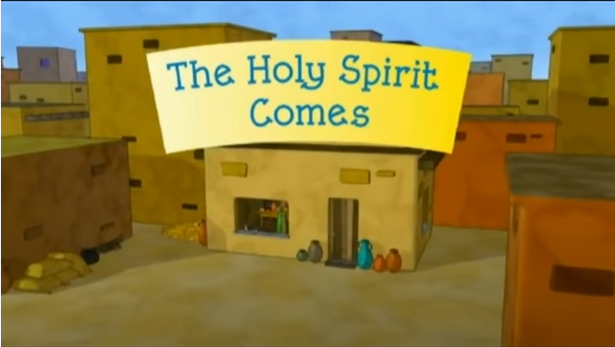

Now that you have read the story of Pentecost, answer this question.
- How were the disciples changed by the coming of the Holy Spirit?

Task: Draw the disciples faces before and after Pentecost either in your books, on some paper or on the template below.
Before the coming of the Holy Spirit After the coming of the Holy Spirit

