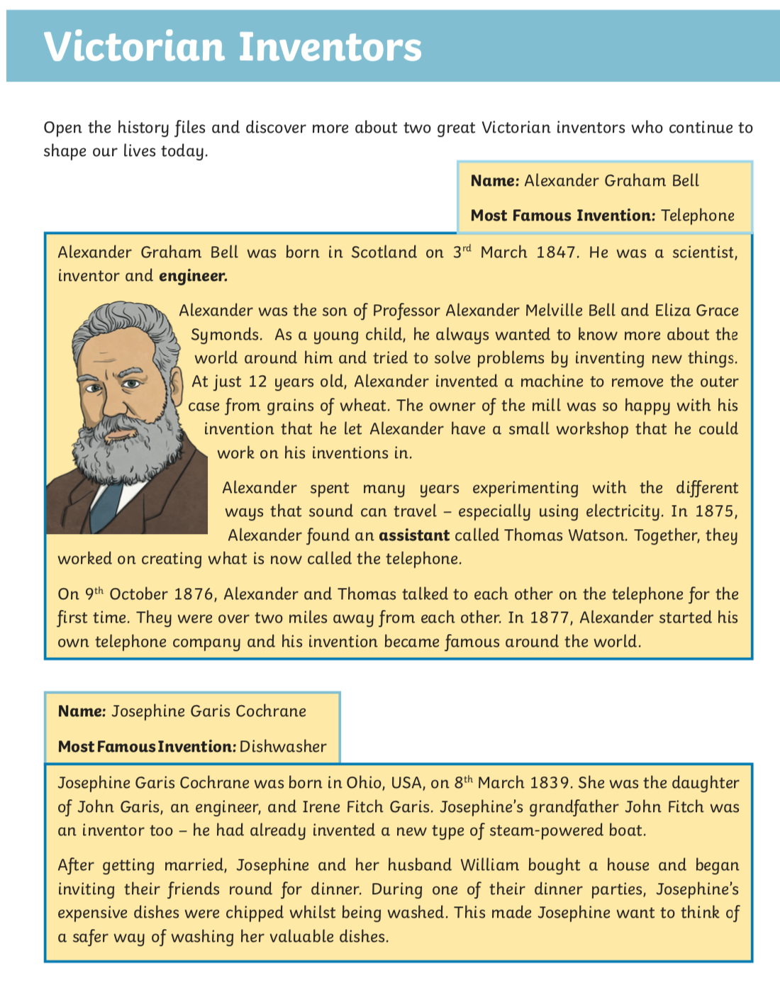

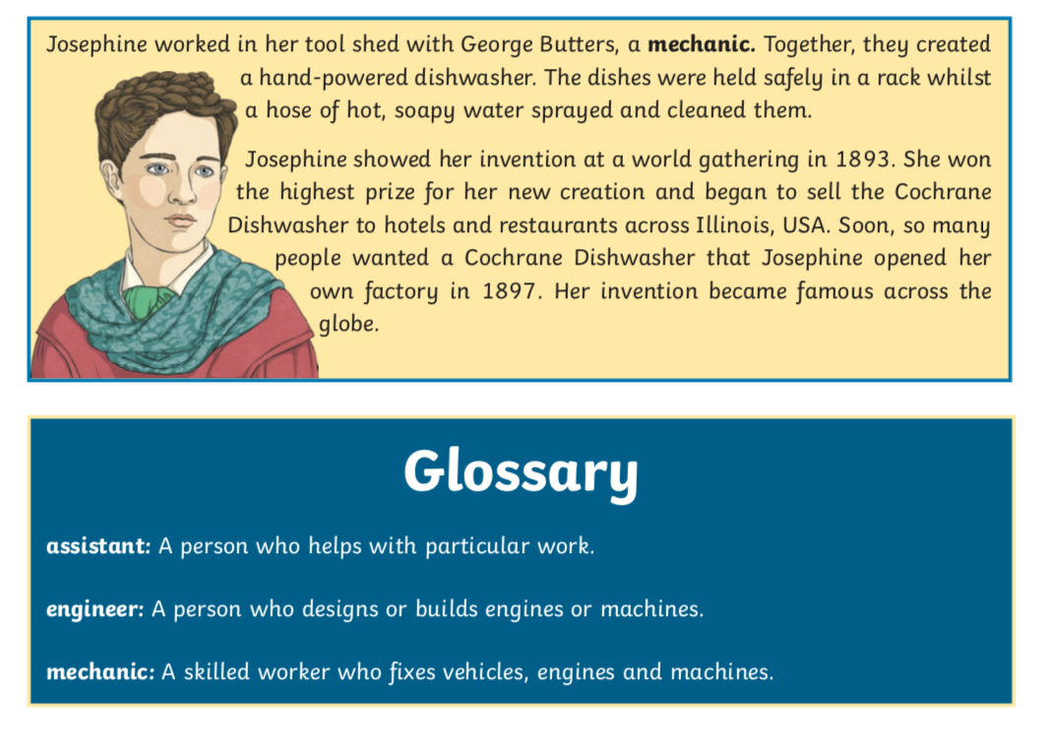

**Questions**

Macintosh HD:private:var:folders:5k:54k53_tn2wl58mfv0m4nnflm0000gn:T:TemporaryItems:Screenshot 2020-05-27 at 21.35.08.png

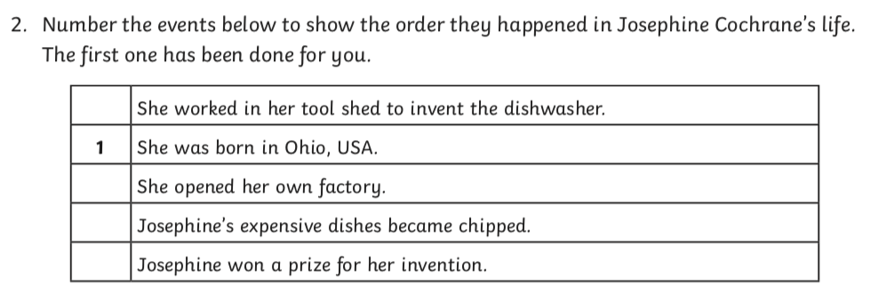

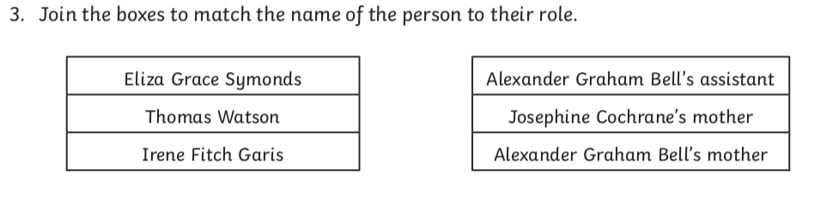



Macintosh HD:private:var:folders:5k:54k53_tn2wl58mfv0m4nnflm0000gn:T:TemporaryItems:Screenshot 2020-05-27 at 21.35.49.png

Macintosh HD:private:var:folders:5k:54k53_tn2wl58mfv0m4nnflm0000gn:T:TemporaryItems:Screenshot 2020-05-27 at 21.36.03.png





**Answers**

1. How old was Alexander Graham Bell when he created his first invention? 12

