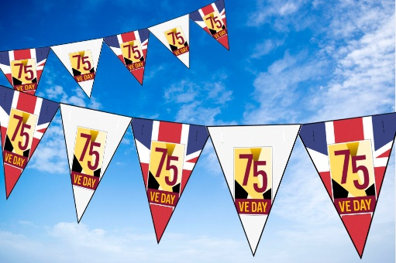

VE Day

Here is a video to explain VE day.

<https://www.bbc.co.uk/teach/class-clips-video/history-ks2-ve-day/z7xtmfr>

Imagine you were there when Churchill gave his speech and you joined in singing with the crowd.

How do you feel? What can you see? What can you hear? What can you smell?

Write a short diary like you were there!

<https://www.bbc.co.uk/teach/class-clips-video/history-ks2-ve-day/z7xtmfr>

<https://www.bbc.co.uk/newsround/48201749>

Make your very own bunting for a VE day party.

Write some short instructions on how you made your bunting.

First get some paper…

Cut out a triangle…

<http://downloads.bbc.co.uk/england/pdf/ve_day_great_british_bunting_instructions.pdf>

Act out Winston Churchill’s famous speech.

Pretend you are Britain’s prime minister and deliver the speech. Choose one line, a paragraph or the whole speech you choose! Use your best expression to sound just like him!

<https://winstonchurchill.org/resources/speeches/1941-1945-war-leader/to-v-e-crowds/>

Have a listen to his speech here how does it make you feel?

Write an acrostic poem about VE day! Think about who people felt about the war being over and everyone who fought for us!

<https://www.youtube.com/watch?time_continue=26&v=NAC2onV6bAg&feature=emb_logo>

V

I

C

T

O

R

Y

Design your very own medal of honour! Draw and describe it.

Use interesting adjectives to describe it. Write short sentences to describe what it looks like.

Use the resource sheet on the website.

Challenge: Why was your medal given? Who could have gotten it?

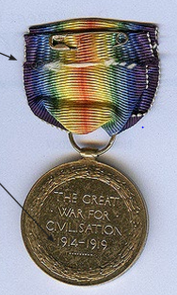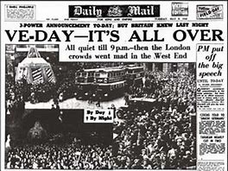

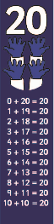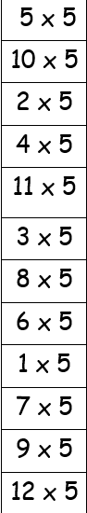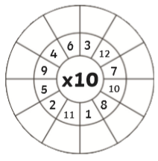

<https://www.mathplayground.com/number_bonds_20.html> Practise your number bonds to 20 using this fun game match up the numbers in the middle to the number that adds to make 20. Select your target number 20 and go!

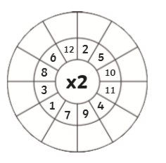

Have fun practising your times tables!

<https://www.ictgames.com/mobilePage/bunny/index.html>

<https://www.topmarks.co.uk/maths-games/hit-the-button>

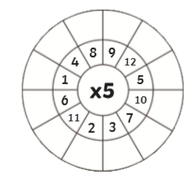

<https://www.bbc.co.uk/bitesize/topics/zjkphbk/articles/zf4sscw>

Choose addition and subtraction and choose your level and go!

Counting in 2s, 3s, 5s and 10s.

<https://www.bbc.co.uk/bitesize/articles/znywjhv>

Use the videos and practise counting from different numbers!

12,14,16

12, 22, 32, 42