Art/DT

Look at the document Roy Lichtenstein Artwork on the website. This has many examples of Roy Lichtenstein’s work. For this piece of work I would like you to look at number 6. This is a rug designed by Roy Lichtenstein.

Look at how he uses different patterns and weaves them together. Look at the colours he uses, contrasting bright reds and yellows with black.

Your task is to design your own version of this rug using the style of Roy Lichtenstein. Create your own patterns and weave them together or use some from this example too. Use similar colours to Lichtenstein to show it is in his style. Use a full page in your book or A4 piece of paper to do this on.

PHSE

Look again at the album covers (images 1 to 3) from the music lesson. The creators of these album covers have not said that Roy Lichtenstein inspired them. However I think they’re suspiciously similar. Write a short for and against discussion (2 points for and 2 points against) to decide if they did copy Roy Lichtenstein’s ideas. Look carefully at the art work, what is similar and what is different. There is no right or wrong answer, you must make you own decision in your conclusion. Finally write a short sentence or two to explain if you think this ok. Remember, Lichtenstein won’t have got any money from the albums, as it’s not technically his work.

P.E.

Look at the pictures 4 and 5 in the Roy Lichtenstein Artwork document. Draw a picture similar to these for your favourite sport in the style of Roy Lichtenstein.

Don’t forget to keep practising your sports during lockdown too; whether it’s dancing in the kitchen, left footed passing off the garden wall or even a good hike every day it’s important to keep practising.

Music

Look at images 1 to 3 on the Roy Lichtenstein Artwork document. These are album covers inspired by Roy Lichtenstein. Pick your favourite album, song or even artist and create an album cover for them in the style of Roy Lichtenstein. Use his examples to help you. Think carefully about what your chosen album/artist/song is about and create a cover that fits with the lyrics.

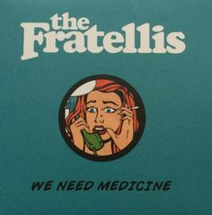

Geography

Roy Lichtenstein is from New York, USA. Research New York and write down your top 10 facts about it.

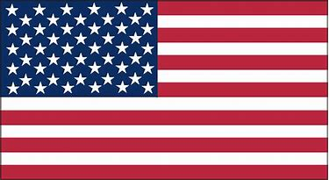

English

There is a new art gallery opening in the North East and they can’t decide which artist should be the main focus in their exhibition. Your job is to persuade the art gallery to display Roy Lichtenstein’s work in their main gallery. This work can be done over multiple days or all in one. Here is what you need to do:

1. Research Roy Lichtenstein, write down a list of cool and interesting facts about him as you go. Here is a good place to start, <https://www.tate.org.uk/kids/explore/who-is/who-roy-lichtenstein>
2. Write down one sentence for each letter in the word persuade (about Roy Lichtenstein) as shown in this video - <https://www.bbc.co.uk/bitesize/topics/zv7fqp3/articles/zr8cmfr>
3. Write your letter to the art gallery to persuade them to display Roy Lichtenstein’s work as their main exhibit. Watch this video for good letter writing techniques - <https://www.bbc.co.uk/bitesize/topics/zv7fqp3/articles/zkq8hbk>

Spelling – homophones

<https://www.spellzone.com/word_lists/list-4664.htm>

Start with study, then use the ’Learn’ button to practise your spellings and finally use the “Games’ button.

Grammar

<https://www.bbc.co.uk/bitesize/topics/zwwp8mn/articles/zsrt4qt>

Watch the video, highlight the relative clause, check your answer and take the quiz at the end.

Activities WB 1.6.2020/ 8.6.2020

Our theme for the next fortnight is ‘Famous Artists’

Work through it at your own pace.

We will be focussing on Roy Lichtenstein and his life and amazing artwork he has created.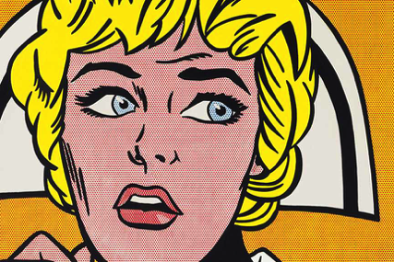

Science

The Museum of Natural History is in New York City (where Lichtenstein was born), the same museum from the film Night at the Museum. This museum has lots of dinosaur skeletons such as the t-rex in the film. Your task is to make a food web for the time of the dinosaurs, you will have to do some research to find some herbivores and carnivores and know what animals ate other animals. You need at least 6 living things in your food web. Look at the food web in the June 1st Resources document to remind you of how they look. You must have a producer!

Reading

Read The Secret Garden, take time to appreciate the artwork throughout this book. <https://www.oxfordowl.co.uk/api/digital_books/20162.html>

ICT

Create anything you would like using a computer to advertise a Roy Lichtenstein exhibition at a local art gallery. You could create a powerpoint about him and his work, a poster on publisher or word or anything else you can think of. If you don’t have access to a computer at home then you can still make a poster by hand.

History

Roy Lichtenstein is from the state of New York in the USA. Read a quick history of the state here:

<https://www.ducksters.com/geography/us_states/new_york_history.php>

One of the most recent historically significant events of the USA happened in New York on September 11th 2001, the twin towers were attacked and destroyed by terrorists, killing thousands of people in the process.

Your task is to create a piece of art in the style of Roy Lichtenstein to represent that day. Remember bright colours, thick black outlines and not a lot of detail. It could be an image of the towers, of a nurse or fire fighter who saved thousands that day or something of your own creation. Look at the 4 images in the June 1st Resources document, these are pieces of work by other artists to represent 9/11. You could use one of these to base your picture on.