Religious Education
Year: One Teacher: Miss Jewitt Week Beginning: 27th April 2020

This week we are going to learn about a very special time in Jesus’ life called The Ascension.
This was when Jesus went up to heaven.
Enjoy reading this very special story from the Bible.
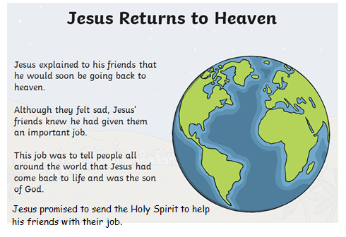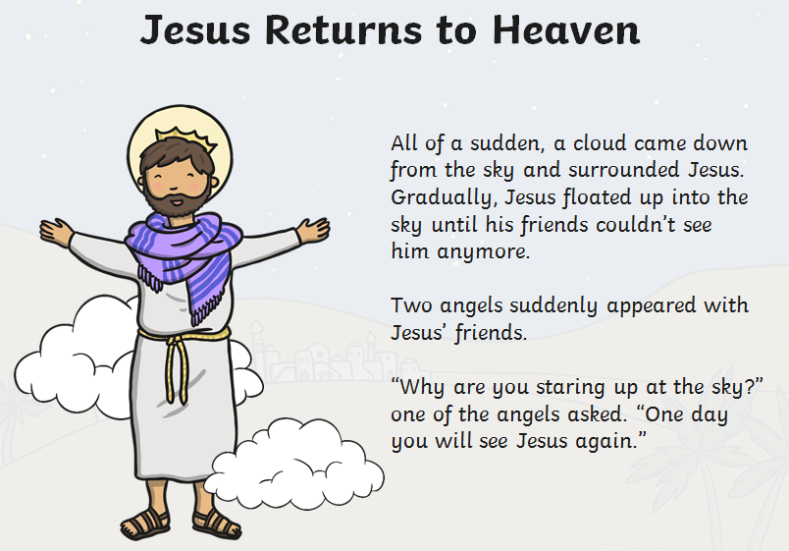
https://www.twinkl.co.uk/resource/t-re-535-ks1-ascension-day-information-powerpoint

Now that you have read the story of the Ascension, answer these questions.
- What did Jesus promise his friends?
- How do you think Jesus’ friends felt?
- How did Jesus go up into heaven?
- Who appeared to Jesus’ friends after he had gone into heaven?
- What did they say to Jesus’ friends?

Task: Fill in the speech bubble on the template below – or you can draw your own picture and add a speech bubble.

On Ascension Day Jesus went back to his Father in Heaven.
He promised to send the Holy Spirit.

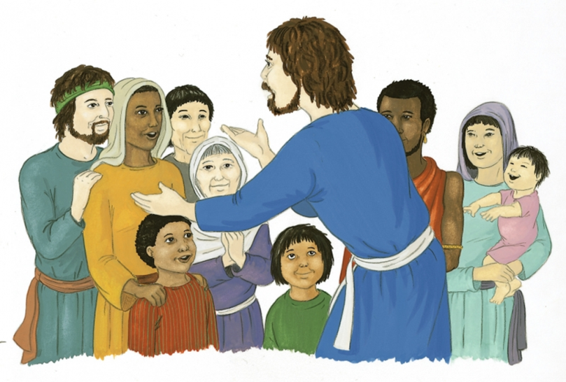
I would love to see your work - please email me when you have finished – a.jewitt300@durhamlearning.net

