Religious Education
Year: 4 Teacher: Mrs Smith Week Beginning: 4th May 2020

Our RE topic for this half term focuses on Pentecost and how Jesus’ resurrection signals ‘New Life’. As Christians, we reflect on how we treat others and consider whether by our words and actions, we have an attitude of serving.
We will start by thinking about how our own Good News makes us feel before moving on to look at how the Good News of Jesus was spread to others and changed their lives.
This week, please share the scripture story, on the next page, with your child and discuss the following questions.

Why did Paul tell everyone about Jesus?

Do you think everyone listened to Paul?

Was his journey always easy?

What would you have done if you were Paul? Why?

Help your child to create a character sketch of Paul before he became a follower of Jesus. Write a second character sketch of Paul after he became a follower of Jesus. How did he change and why?

There is an example template you could use on the page after the scripture.

Don’t forget to email me your good news when you have finished – k.smith201@durhamlearning.net

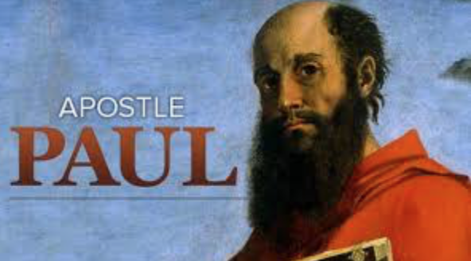

Paul was originally called Saul. He was a Jew who came from Tarsus. He grew up in a Jewish home. He was a Pharisee and did everything he could to be a good man. He kept every rule there was to keep, but he did not like the followers of Jesus. He did his best to wipe them out; however, God filled his mind and heart with the light of truth, and he recognised who Jesus was. He knew he owed everything to God’s love. All he wanted to do was spread the Good News of that love all over the world. When he became a Christian his name was changed to Paul.

He travelled many thousands of miles, on foot, on horseback and by boat to spread the Good News, mainly to the Gentiles, the people who were not Jews. In every place, he told people about Jesus and the power of the Holy Spirit. He explained the Good News that Jesus had come to bring – God loves everyone. He told them how Jesus had died and been raised to a new life by his Father in heaven and how the Holy Spirit helps people. He told them that Jesus wanted them to share this new life. When they asked him what they had to do to live this new life, he told them that they must believe and be baptised and try to live like Jesus, loving God and loving one another. They were to share their faith with one another, pray together and break bread together as Jesus had done with his friends at the Last Supper.

