Religious Education
Year: 4 Teacher: Mrs Smith Week Beginning: 1st June 2020

Our RE topic for this half term focuses on Confirmation. In the Old Testament, we hear stories of how God called those he had chosen to do his work. Read the ‘Call of Samuel’ and the ‘Call of David’ (see below). God does not choose people for the same reasons as we might. God looks at the heart and not at the outer appearance.
Questions to discuss:

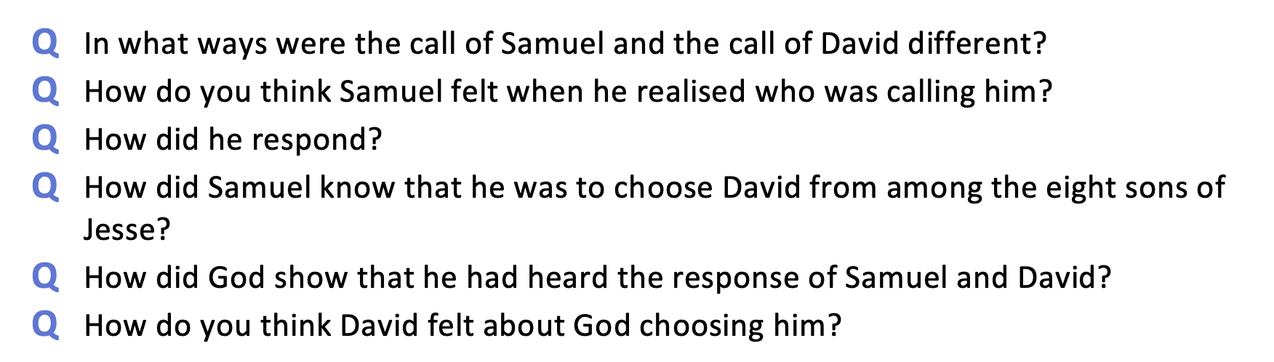

In the New Testament Jesus chose twelve men to be his Apostles to tell everyone the Good News of God’s love. Read ‘Come Follow Me’ (see below).
Your task is to choose to be one of the apostles and write a Facebook post (see below) to your family and friends explaining what you are doing and why you are doing it.

Don’t forget to email me your Facebook post when you have finished – k.smith201@durhamlearning.net

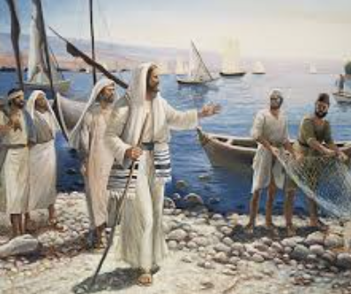

The call of Samuel. https://www.youtube.com/watch?v=Fuukb6xGZTI
God chooses David. https://www.youtube.com/watch?v=aVUCz1AhLZM

Jesus calls his disciples. https://www.youtube.com/watch?v=CoOQmEs0mQ4

Example Facebook post
