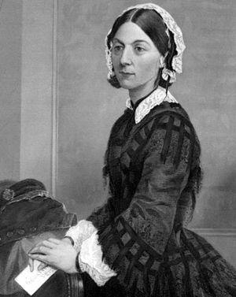

Thursday - English and PSHE.

You have a bit more research to do today. Primarily, I would like you to research the role of the modern day nurse. Find out how to become a nurse and what nurse does. Find out what types of nurse there are and how much nurses get paid. Write down notes of what you find. Secondly, imagine you are a hospital patient, think about what kind of qualities you would want your nurse to have e.g. caring, kind, compassionate etc. Write a couple of sentences to explain this. This NHS website might be a good place to start: <https://www.stepintothenhs.nhs.uk/careers/childrens-nurse>

People Who Help Us

Week 1 – Nurses

Kindness is Key.

Monday - Reading

Complete the Florence Nightingale comprehension task. Read the text carefully and answer the questions in full sentences in your book. Use this video to get some extra information: <https://www.bbc.co.uk/teach/class-clips-video/history-ks1-ks2-florence-nightingale/z68fcqt>



Tuesday and Wednesday – English and Art.

Research Florence Nightingale in preparation for presenting. Pretend you are going to teach year 3 all about Florence Nightingale. Gather your research under subheadings, you could use: Family, Early Life, The Crimean War and Later Life. Feel free to make up your own if you have better ideas. Once you have gathered all of your information then present it in an appealing way for people to see using a big poster. You could have a drawing in the centre and facts around your image or something like this. I am interested in your art as well as your information. These links may help you: <https://www.bbc.co.uk/bitesize/topics/zns9nrd/articles/znsct39>

<https://www.theschoolrun.com/homework-help/florence-nightingale>

Friday – English.

Today I would like you to write a short job description for a nurse. You must include a paragraph about which type of nurse you are looking to employ and what they would have to do in their job and then another paragraph to explain what you will be looking for in people who apply, what qualities do you want to see? Think about your presentation, you want the best people to apply so make your job advertisement eye catching and appealing. See the English resources for an example format.

Reading

As well as this work it is very important you keep up your reading. Use this link to access some free e-books: <https://www.oxfordowl.co.uk/for-home/find-a-book/library-page>. This week I want everyone to read Air Raid as it follows on from last weeks work around WW2.

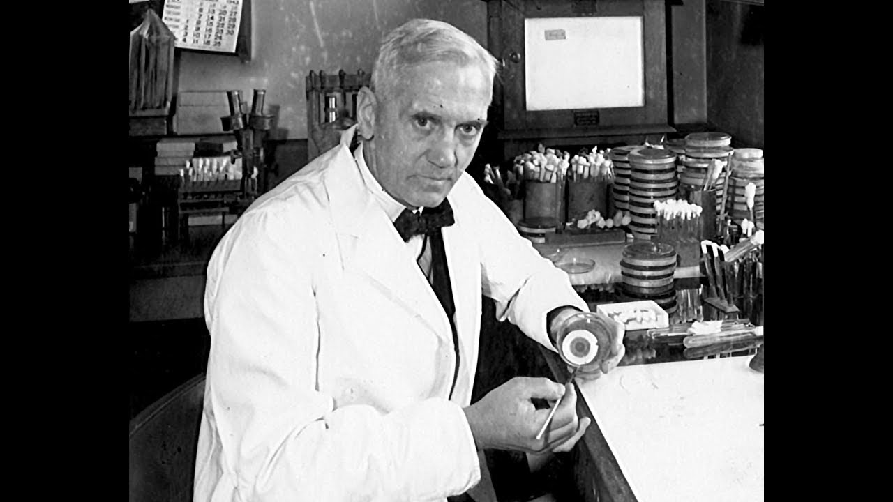

Monday - PSHE

Have a think about who is still going to work at the moment, our key workers. Write a list of as many key workers as you can think of e.g. nurses, fire fighters, shop assistants etc. Next to each job write down why you think it is important that they keep working.

Thursday – English.

Tomorrow you are going to write a letter to one of the key workers you picked to say thank you, I would choose the job you know the most about. Today you are going to plan your letter. In your first paragraph you are going to introduce yourself, name, where you go to school, what interests you have / sports you play etc. Second paragraph will be to explain you have been researching key workers and you choose this job as a very important one, explain why you think it is important, what you have learned in your research. Finally write a thank you, show this person how important they are and how much you and others appreciate the job they are doing. Remember today is your plan, write subheadings for each paragraph and bullet point your key points. Tomorrow you will write it up properly. Use this link to help think about your sentence structure: <https://www.bbc.co.uk/bitesize/topics/z4hrt39/articles/zfxfwty>. I would like to see everyone use at least two complex sentences in their writing.

Friday – English.

Today you are going to write a letter to your chosen key worker to say thank you. Use your plan from yesterday to help you. Remember your letter structure, return address in the top right corner, start with dear whoever and end with yours sincerely and your name. Use this link to help: <https://www.bbc.co.uk/teach/skillswise/writing-a-letter/zbc8vk7>

People Who Help Us

Week 2 – Kindness is Key

Tuesday – PSHE and ICT

Look at your list from yesterday, today I want you to pick two that you think are very important or even two that mean a lot to you. Maybe someone in your family has one of these jobs or maybe it’s a job you could see yourself doing in the future. Research a bit further into the two careers you have chosen, just like we did last week for nurses. Find out how to get into that career, what qualifications you need, where they work, what they do on a daily basis, how much they get paid etc. Use the job description template from last week to help you.

Wednesday - Reading

Look in the resources for this week (May 18th). There is a VIPERS reading task to complete all about Alexander Fleming. Answer the questions in full sentences in your books.



Reading

Last week we looked at a fictional text so this week I would like you all to read a non-fiction book. Please read Exploring the Deep this week. <https://www.oxfordowl.co.uk/for-home/find-a-book/library-page>.