Dear Year Two,
I hope you are all staying safe and enjoying your learning at home. I am missing you all very much but seeing your photographs make me smile every day! I have been doing the same as you these past few weeks, keeping inside and staying safe! I have been taking my five dogs for a walk for my daily exercise and enjoying some of the sun in my garden! I hope you have been enjoying this lovely weather too!
I have been going into school each week to take care of the key workers children and we have been getting on with the lovely home learning tasks just like you! It is still very strange not seeing you in our classroom, but I can’t wait to see you as soon as it is safe!
From this week your jobs look a little bit different, but they are just as interesting and fun! This planning will take you all the way to half term. We are going to be learning all about the amazing Florence Nightingale and how she is so important, just like all the amazing keyworkers out there! We are also focusing on kindness and how important it is to spread it around! I know all of you are super at sharing kindness so I can’t wait to see how you get on with the lovely tasks I have set! Don’t worry if you haven’t got a printer you don’t need to print off just put it on screen (if possible) and write down in your book!
If you need any help or have any questions please just email me at y.harker300@durhamlearning.net
There is no pressure to do all tasks set just try your best and have fun with your learning! Keep reading, playing your timetable rockstars (we can have a battle) and trying hard with your spelling!
I am so proud of each and everyone of you, you are all amazing and making me and everyone at Our Lady of Lourdes beam with pride!
You will also be getting a book from school with a kindness calendar for you to draw/ write all the kind things you are doing! I can’t wait to see what you get up to! I will also fill my calendar in too so you can see what I have been getting up to!
There will be set days, but you can pick and choose what you would like to do if you prefer! Keep sending those lovely photos so I can put onto our home learning gallery.
We will meet again Year 2!
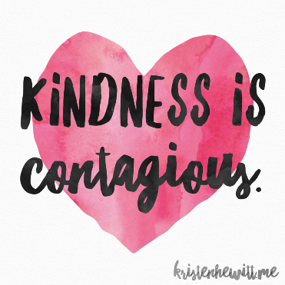
Miss Harker

