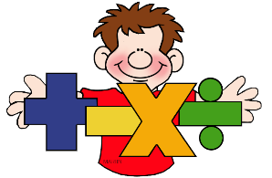
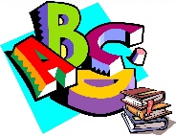
English and Maths

Year: 4 Teacher: Mrs Smith Week Beginning:27/04/2020
Weekly Reading Task: | Read the History Hackers chapters 7-9 (history hackers.pdf)
 | English Activity/ Objective | Maths Activity/Objective
Monday | Task 1: Reading comprehension.  Answer the questions about Chapters 4-6 of History Hackers in your book. Once you have finished, check your answers. | Task 1: Week 2 Lesson 1 - Divide 2-digits by 10  https://whiterosemaths.com/homelearning/year-4/  After watching the video, click on get the activity and answer the questions in your book. Once you have finished, check your answers by clicking on Get the answers.
Tuesday | Task 2: Synonyms and antonyms  Learn about Synonyms and Antonyms from the video  Rewrite the paragraph using your own choice of synonym for each highlighted word. | Task 2: Week 2 Lesson 2 - Hundredths  https://whiterosemaths.com/homelearning/year-4/  After watching the video, click on get the activity and answer the questions in your book. Once you have finished, check your answers by clicking on Get the answers.
Wednesday | Task 2: Synonyms and antonyms  Rewrite the paragraph using your own choice of antonym for each highlighted word. | Task 3: Week 2 Lesson 3 - Hundredths as decimals  https://whiterosemaths.com/homelearning/year-4/  After watching the video, click on get the activity and answer the questions in your book. Once you have finished, check your answers by clicking on Get the answers.
Thursday | Task 3: Past and Present Tense  https://www.bbc.co.uk/bitesize/topics/zrqqtfr/articles/z3dbg82  Watch the video about tenses. Complete the online activity to match the verb with the tense. In your book, write a sentence using the different forms for each tense. Now complete the past and present activity in your book. Check the answers at the end. Finally, you can try the quiz on the website. | Task 4; Week 2 Lesson 4 - Hundredths on a place value grid  https://whiterosemaths.com/homelearning/year-4/  After watching the video, click on get the activity and answer the questions in your book. Once you have finished, check your answers by clicking on Get the answers.
Friday | Task 5: Research coins and write a blog  Pick a period from history mentioned in chapter 4 and research what their coins looked like. Then write a blog post for the class blog explaining what you have discovered, including pictures  Challenge! - find out how people traded before coins and money were invented. | Task 5: Rounding practise and challenge  https://www.topmarks.co.uk/maths-games/daily10  Choose level 4, Rounding, Up to 9,999 to nearest 10.  Complete the activity in your book and check your answers at the end.  Now try the challenge from the Nrich website https://nrich.maths.org/1138

