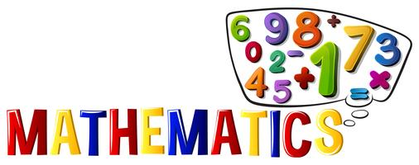
Maths Resources May 18th

Wednesday

Fill in the missing numbers:
- 2,000 + 3,000 =
- 1,000 + …….. = 6,000
- 4,500 + 3,000 =
- 12,000 + 9,000 =
- 15,000 + …….. = 31,000
- 3,370 + 7,000 =
- 8,020 + 13,000 =
- 31,000 + ……. = 99,000
- 56,901 + …….. = 72, 901
- 21,000 + …….. = 100,000

Thursday

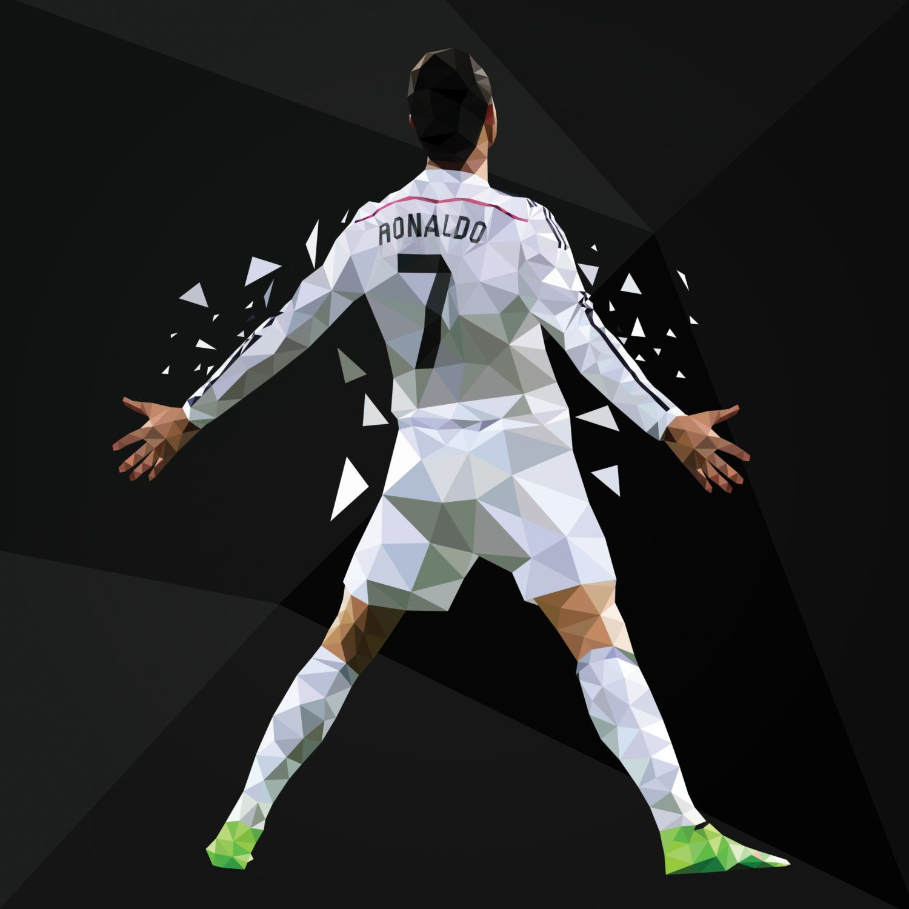
- If I have 7,890 followers on Monday and I gain another two thousand followers on Tuesday, how many followers do I have in total?
- Ronaldo has scored 539 goals in his career (fact). How many goals would he have scored if he had 1,500 more goals?
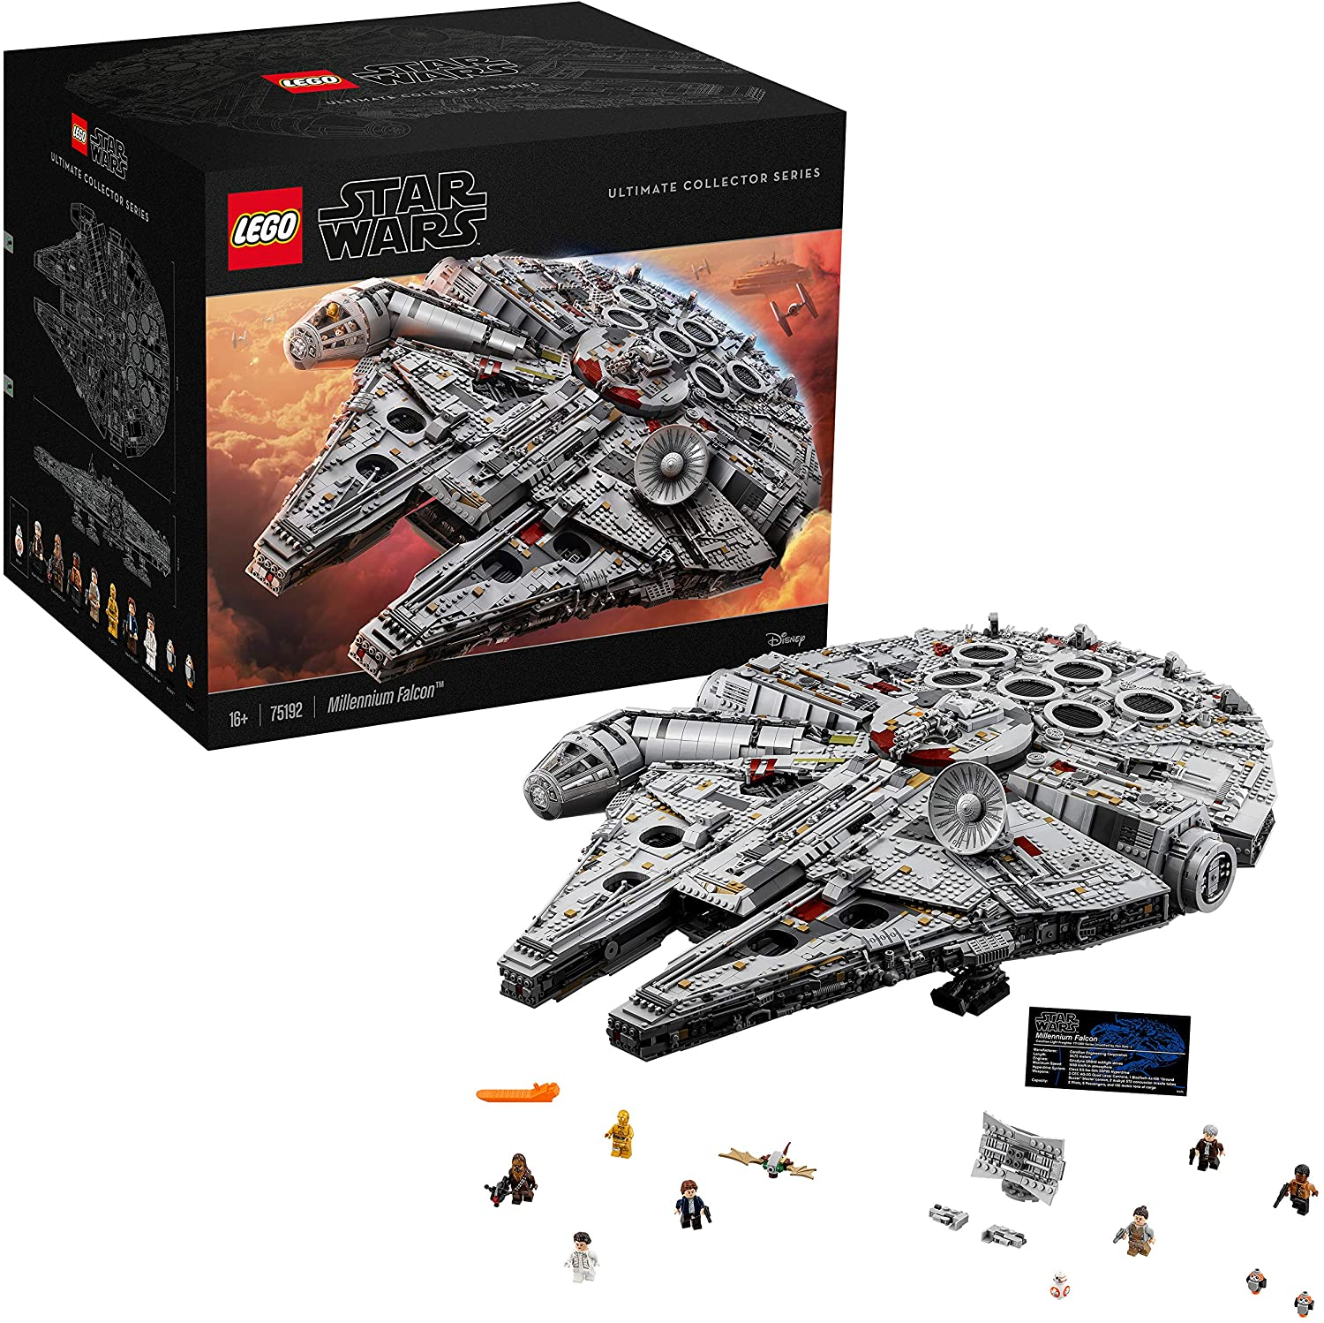
- The biggest Lego set you can buy has 7541 pieces in it. It is the Millennium Falcon from Star Wars. How may pieces would it have if we added an extra thirteen thousand?
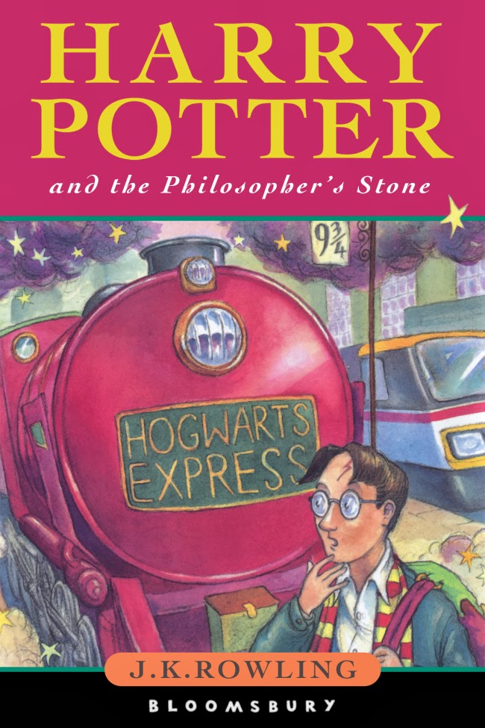
- I mined 27,500 blocks on Minecraft on Tuesday. I then mined another 14,000 blocks on Wednesday. On Friday I only managed to mine nine thousand blocks. How many blocks did I mine altogether?
- My farm is 22,500m2. My neighbour’s farm is twice the size of our farm. How much area do our combined farms take up? (Warning this is a 2-step problem)
- There are 235 Goosebumps books in total. How many more would R.L. Stine need to write to reach 1,000?
- There are 76,944 words in Harry Potter and the Philosopher’s Stone (this is true). J.K. Rowling left out 4 chapters that totalled fourteen thousand five hundred words (this is not true). If she had left the 4 chapters in how many words would there have been altogether?
- My video has 14.4k views. It gets another 12,500 views after 1 week. It then blows up and gets forty-nine thousand views in it’s 2nd week. How many views does my video have in total?
- There have been 28,642 goals scored in the Premier League. How many more goals need to be scored to reach fifty thousand?

Friday

- 2,750 + ……. = 13,000
- The answer is 14,500. What could the question be?
- What is 12,000 more than nineteen thousand?
- There are 1,000 years in a millennium. The Stone Age ended around 5 millenniums ago. How many years ago did it end?
- I have 37,000 followers. Mrs Wright has 39,500 followers. Miss Brack has 13,000 followers. How many followers do we all have in total?

