Tuesday 12th May
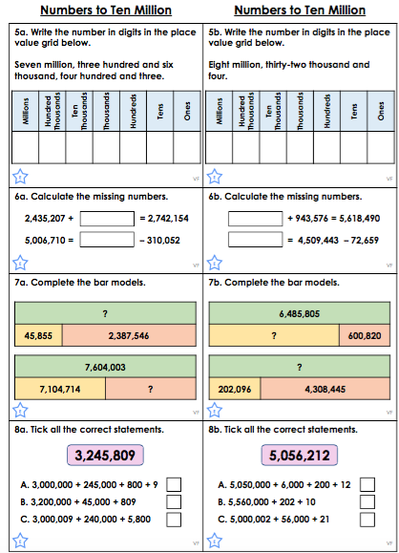

Wednesday 13th May

Copy and complete the following into your book.

- 10,000,000 – 5,000,000 = 6. 2,361,000 + ………. = 10,000,000
- 10,000,000 – 3,500,700 = 7. 34,578 + ………. = 10,000,000
- 10,000,000 – 6,960, 309 = 8. 2,675,000 + 7,001,923 =
- 7,500,000 + 2,500,000 = 9. 4,091,851 + 3,982,037 =
- 2,309, 972 + 7,690,028 = 10. 10,000,000 - ………… = 8,012,809

Thursday 14th May

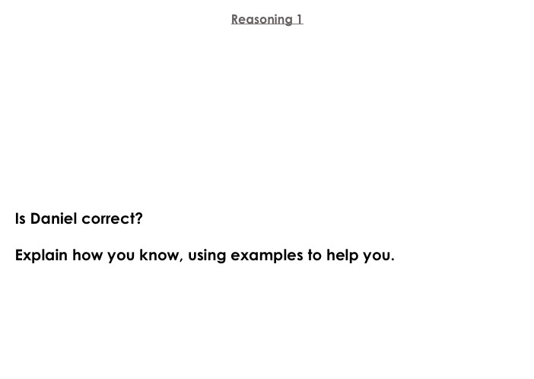
If I add two hundred thousand to any
six-digit number, it will only ever be the hundred thousands column that I will need to change.
Daniel

Insert the top 4 number cards into the empty spaces so that the number sentence is true. How many different combinations can you find?

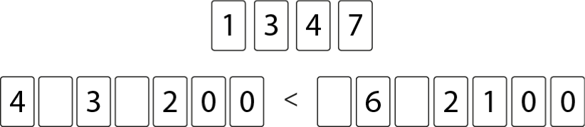

Friday 15th May

- How many ten thousands are in 2,308,962?
- How many digits are there in ten million?
- 9,815,632 + ……. = 10,000,000
- How many millions are in 8,983,627?
- 2,_3_,_89 > 2,_99,0_1. Fill in the blanks to make the number sentence correct.
- If I have 3.9million followers and my friend has 1,209,364 followers, how many do we have altogether?
- Ireland has a population of 4,937,786. The Isle of Man has a population of 85,033. What is the difference in population size?

