Maths Activity 2 – WB 18.02.2020

If 15 + 7 = 22  150 + 70 = ______ | If 35 + 6 = 41  3500 + 600 = ______
If 22 + 9 = _____  220 + 90 = ______ | If 42 + 8 = _____  4200 + 800 = ______
If 17 + 6 = _____  170 + 60 = ______ | If 53 + 9 = _____  5300 + 900 = ______
If 54 + 8 = _____  540 + 80 = ______ | If 3 + 56 = _____  300 + 5600 = ______
If 28 + 3 = _____  280 + 30 = ______ | If 7 + 27 = ___  700 + 2700 = ______
Starting with the numbers shown below. Complete the calculations
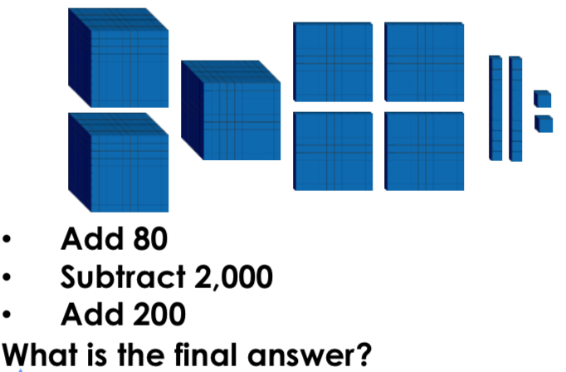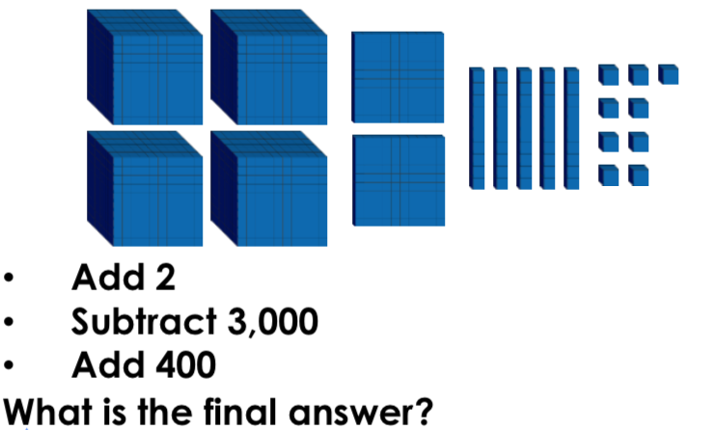
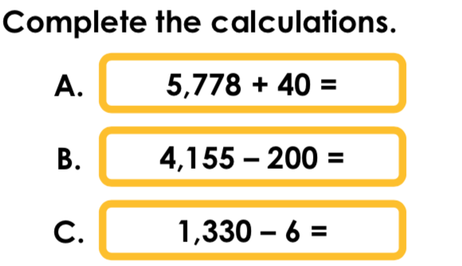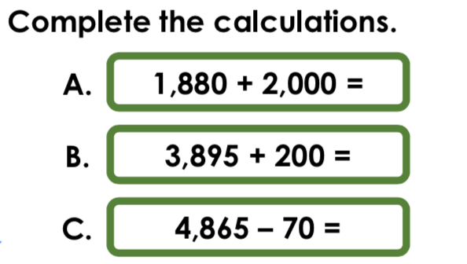

Answers
If 15 + 7 = 22  150 + 70 = 220 | If 35 + 6 = 41  3500 + 600 = 4100
If 22 + 9 = 31  220 + 90 = 310 | If 42 + 8 = 50  4200 + 800 = 5000
If 17 + 6 = 23  170 + 60 = 230 | If 53 + 9 = 62  5300 + 900 = 6200
If 54 + 8 = 62  540 + 80 = 620 | If 3 + 56 = 58  300 + 5600 = 5800
If 28 + 5 = 33  280 + 50 = 330 | If 7 + 27 = 34  700 + 2700 =3400

1,702 1,661
A – 5,818 A – 3,880
B – 3,955 B – 4,095
C – 1,324 C – 4,795

