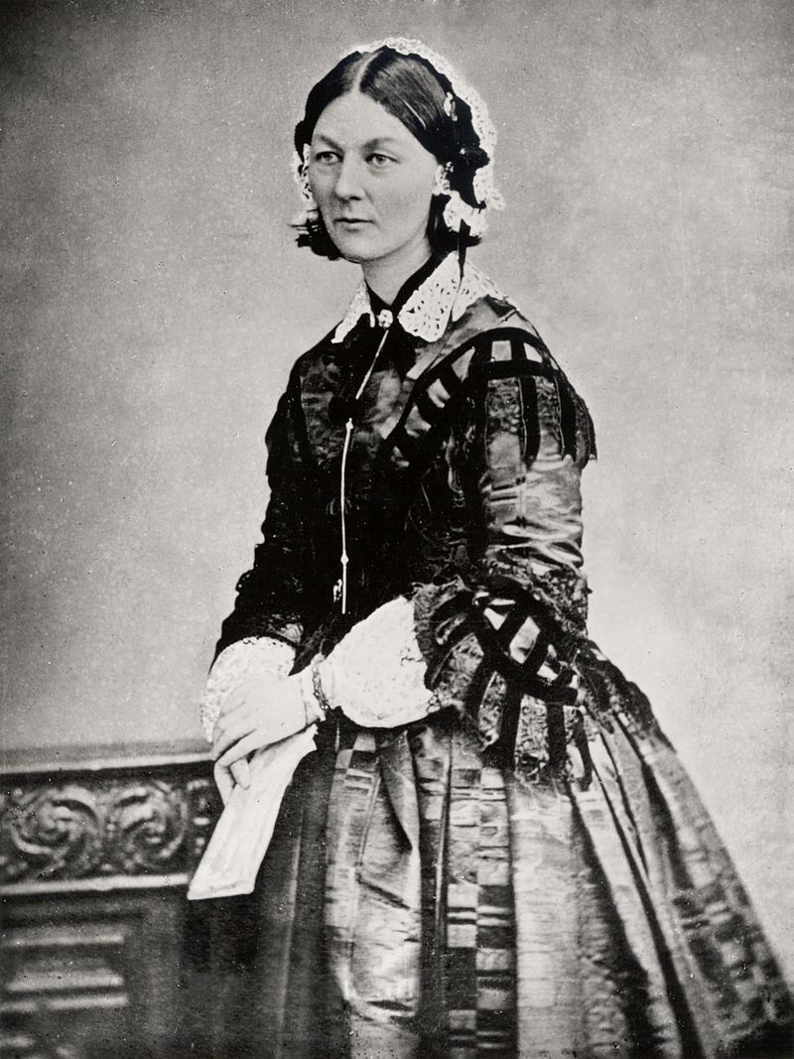
Florence Nightingale of Derbyshire
LIGHTING THE WAY!
Monday, 9th July 1860
POLITICIANS AND SOLDIERS ALIKE ARE JOINING TOGETHER TO CELEBRATE THE ACHIEVEMENTS OF NURSE MISS FLORENCE NIGHTINGALE IN THE CRIMEA. Miss Nightingale is the daughter of Mr William Nightingale, a gentleman of Lea Hurst, Derbyshire.
Although a gentlewoman, Miss Nightingale has chosen to shun the traditional path of marriage and family, in pursuit of the care and well-being of our brave soldiers fighting the Russians in the Crimea.
Her modern ideas have been a source of some sorrow to her parents. However, they are immensely proud of her humanitarian efforts.

CONNECTIONS
It is due to her friendship with former Secretary of State for War, Mr Sidney Herbert, that Miss Nightingale was able to travel to the Crimean region after hearing the horrifying reports on the conditions there, particularly for the wounded.
In 1854, Miss Nightingale and her team of 38 newly trained volunteer nurses and 15 Catholic nuns, travelled to their posting near Balaklava, home of the British camp.
“We found the wounded soldiers in absolute squalor. The staff who were charged with caring for them were completely overwhelmed and there was a terrible lack of hygiene and cleanliness.” says Miss Nightingale. “I knew that our first job was to open the windows to allow in the natural light and to allow the dangerous smells to escape. It was also essential that handwashing and other hygienic practices be introduced.”

THE LADY WITH THE LAMP
However, it is not her devotion to cleanliness that has brought Miss Nightingale to public attention, but rather her role as the comforting ‘lady with the lamp.’ Soldiers who returned from the Crimean war have spoken with fondness of how, long after others had retired to bed, Miss Nightingale spend time with them during the lonely, dark hours of the night. There can be little doubt that this compassion has aided their recovery.

TRAINING
And so it is today that the Nightingale Training School for nurses has been established at London’s St Thomas Hospital. The school was made possible through generous public donations to the Nightingale Fund. It is hoped that this will improve the status of nursing as a worthwhile vocation for respectable women.

Questions

- Give 3 features of a newspaper report from this text: (3 marks)

(ii)
(iii)

- Why does the text suggest Florence Nightingale was unusual for a woman of her time? (2 marks)

- Who was Sidney Herbert and what did he do for Florence Nightingale? (2 marks)

- Why were conditions so bad for the soldiers at Balaklava? How did Florence Nightingale attempt to improve the situation? (3 marks)

- How did Florence Nightingale get the nickname ‘The Lady with the Lamp?’ (2 marks)

- According to the text, why was the Nightingale Training School established? (1 mark)

a) To raise money

b) For Florence Nightingale to be a better nurse

c) To send more nurses to the Crimea

d) To make nursing a professional and respectable job

