English and Maths

Year: 4 Teacher: Mrs Smith Week Beginning:04/05/2020
Weekly Reading Task: | Read about VE Day  https://www.bbc.co.uk/newsround/48201749
 | English Activity/ Objective | Maths Activity/Objective
Monday | Task 1: Reading Comprehension – VE day  Watch the video about VE day  https://www.bbc.co.uk/teach/class-clips-video/history-ks2-ve-day/z7xtmfr  Read the invitation and letters about VE day and answer the questions in your book. | Task 1: Number bonds  Read and watch the videos about number bonds to 100  https://www.mathswithmum.com/number-bonds-to-100/  Practise number bonds to 100  https://www.topmarks.co.uk/maths-games/hit-the-button  Watch the video to learn about number bonds to 1000  https://www.youtube.com/watch?v=Yjiysu2SlPA  Practise your skills  https://www.studyzone.tv/game276-codee487e3c9f8d87da4581a9a5c82640e6e#game
Tuesday | Task 2: Poetry  Watch the poem being performed.  https://www.bbc.co.uk/bitesize/clips/zkpmhyc  The box is filled with magical moments, experiences and fantastic events.  Work through lesson 3 from  https://www.thenational.academy/online-classroom/year-4/english#subjects to identify the features and language used in poetry. | Task 2: Practise number bonds  https://www.transum.org/software/SW/Dice/  Make the settings as shown.  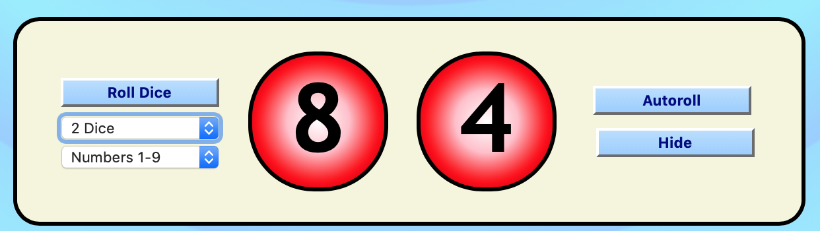  Click Roll dice to make a 2-digit number (i.e. 29). Use part/whole models or bar models to record bonds to 100.  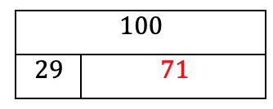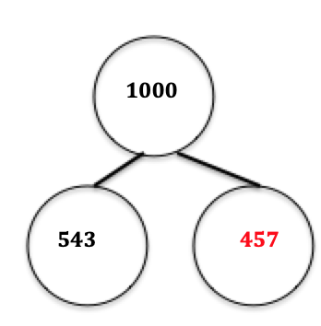  Change the number of dice to 3. Repeat for 3-digit numbers.
Wednesday | Task 3: Expanded Noun Phrases  Work through the page about expanded noun phrases.  https://www.bbc.co.uk/bitesize/topics/zwwp8mn/articles/z3nfw6f  Work through lesson 4 from  https://www.thenational.academy/year-4/english/features-of-poetry-year-4-wk1-3 | Task 3: Reasoning and Problem solving  Use your knowledge to explain your reasoning and solve problems.  Week 3 Reasoning and problem solving.doc
Thursday | Task 4: Writing  Working through lesson 5 from  https://www.thenational.academy/year-4/english/poetry-write-a-repetitive-poem-year-4-wk1-5  Write 3 verses of your own following the pattern of ‘The Magic Box’. Try thinking about poetic features, VE Day, war and the virus to develop your imagination. | Task 4: Check your skills by answering the questions.  Bonds to 100  https://www.studyzone.tv/game275-code13fe7c386fa4ad7bb0ecdf05c8cec747#game  Bonds 10 1000  https://www.studyzone.tv/game277-code71792b287c7b987c78bfe788c25c635b#game
Friday | Bank Holiday – VE Day

