[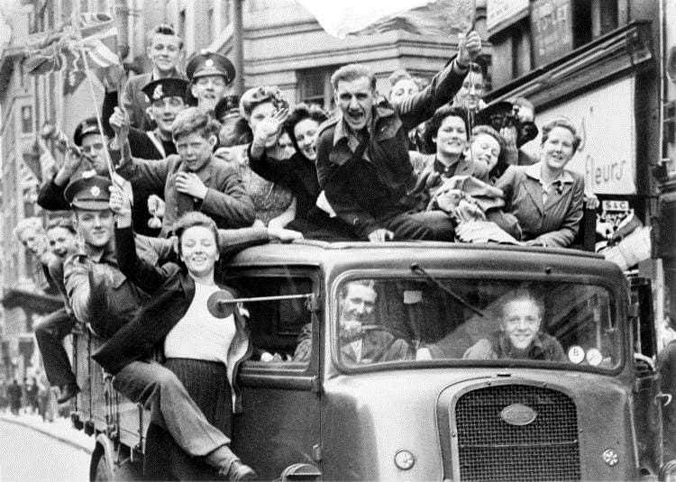](https://www.google.co.uk/url?sa=i&url=https%3A%2F%2Fwww.bishopsstortfordindependent.co.uk%2Fnews%2Fwhere-were-you-on-ve-day-share-your-memories-of-momentous-occasion-9102039%2F&psig=AOvVaw1m6XHZF0cwSYydJcpmORSA&ust=1588240823170000&source=images&cd=vfe&ved=0CAIQjRxqFwoTCNCvgKywjekCFQAAAAAdAAAAABAD)

I would like you to write a short letter to ask for permission to hold a VE Day street party!

You will need to convince the reader that it is a good idea to have a street party and why it is important that we celebrate VE Day!

VE day was declared as the 8th May 1945 as the German leaders signed a treaty (legal document) to announce they were officially ending their fighting in Europe. This happened 75 years ago – why do you think it is important that we still learn about VE Day today?

<https://www.bbc.co.uk/newsround/48201749>

VE Day

English Activities

Here is a video to explain VE Day.

<https://www.bbc.co.uk/teach/class-clips-video/history-ks2-ve-day/z7xtmfr>

Captain Tom Moore is a WWII Veteran and has been making headlines across the world recently. Write a short biography to explain who he is and why he has been so talked about over the last few weeks!

<https://www.bbc.co.uk/newsround/52471924>

Imagine you were there at the first VE Day. Write a short diary entry about how you would feel to hear that the war was over.

<https://www.bbc.co.uk/newsround/48201749>

Imagine you were going to host a VE Day party. I would like you to write a plan for the day, including:

Where would you hold it?

Who would you invite?

What would happen on the day?



This time I would like you to sort the numbers on a number line

using numbers to 2 d.p. (2 decimal places e.g. 1.26)

<https://mathsframe.co.uk/en/resources/resource/37/placing-numbers-on-a-number-line>

Note down all the prime numbers between 1 and 50

<https://www.bbc.co.uk/bitesize/topics/zfq7hyc/articles/z2q26fr>

Use this activity to place numbers on a number line.

I would like you to use whole numbers today.

<https://mathsframe.co.uk/en/resources/resource/37/placing-numbers-on-a-number-line>

[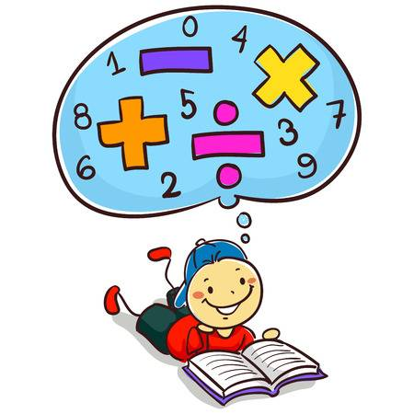](https://www.google.co.uk/url?sa=i&url=https%3A%2F%2Fwww.123rf.com%2Fstock-photo%2Fmath_cartoon.html&psig=AOvVaw2gu3KisDtjV7TxFexH2YdV&ust=1588244172581000&source=images&cd=vfe&ved=0CAIQjRxqFwoTCODHhOC8jekCFQAAAAAdAAAAABAJ)[](https://www.google.co.uk/url?sa=i&url=https%3A%2F%2Fdlpng.com%2Fpng%2F6394305&psig=AOvVaw2gu3KisDtjV7TxFexH2YdV&ust=1588244172581000&source=images&cd=vfe&ved=0CAIQjRxqFwoTCODHhOC8jekCFQAAAAAdAAAAABAD)

Useful maths links:

BBC Bitesize:

<https://www.bbc.co.uk/bitesize/subjects/z826n39>

Times Tables Rockstars:

<https://ttrockstars.com/>

Use the below activity to sort negative numbers on a number line.

<https://mathsframe.co.uk/en/resources/resource/37/placing-numbers-on-a-number-line>