Weekly Reading Task: | Each day recap Phases 3, 4 and 5 sounds and blends. Play the Buried Treasure game:  https://new.phonicsplay.co.uk/resources/phase/5/buried-treasure
 | English Activity/ Objective | Maths Activity/Objective
Monday | VE Day  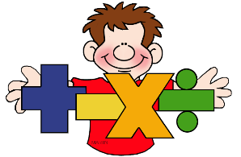  English and Maths  Y1 Miss Jewitt Week Beginning: 4th May 2020  On the 8th May 2020 Britain will celebrate VE Day. This week in our lessons we will be finding out about what VE day is.  Task 1: With your families find information about VE day. This is a very good site to look at: https://www.bbc.co.uk/newsround/48201749  Task 2: Answer the following questions.  1) What does VE stand for?  2) How do you think all the people were feeling when they heard that the war in Europe had ended?  3) What kind of things did the people do to celebrate?  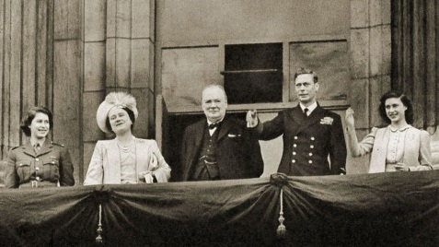  Find this picture towards the bottom of the document and answer the next questions.  4) Who was the prime minster when the war in Europe ended? Can you point to him?  5) Who was the king when the war in Europe ended? Can you point to him?  6) Was the king related to our queen (Elizabeth II) ? How?  7) Is our queen in the photo? Can you point to her? How is she different to now? | Number bonds to 10  Can you tell your families… the number bonds to ten (numbers that add together to make 10)  0 1 2 3 4 5 6 7 8 9 10  e.g 0 + 10 = 10 1 + 9 = 10  Task: Play ‘Hit the Button’ game. https://www.topmarks.co.uk/maths-games/hit-the-button  Click on the green ‘Number Bonds’ button.  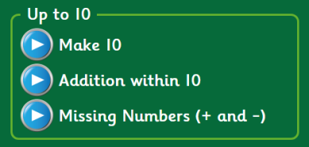  Try these three games today.  Extra: Remembering our money work from last weekcan you write down the number bonds to 10p.  e.g. 1p + 9p = 10p  2p + 8p = 10p
Tuesday | Task: What can you remember about VE day? Tell your family.  Look at the pictures at the bottom of this page and the website from yesterday https://www.bbc.co.uk/newsround/48201749 Write about some of the things the people did when they heard that the war was over in Europe. You can decide with your family how you would like to show this information – you could make a poster, or a leaflet, or write it down in a book or on some paper. See if you can use the conjunctions ‘and’ or ‘because’.  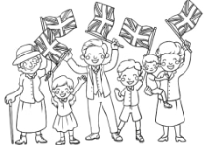  e.g  The streets were very busy and everybody felt so happy that the war was over. Some people waved flags.  The people went to church because they wanted to say thank you to God. | Number bonds to 10  Task: Play ‘Spring number’ game.  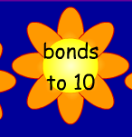  https://www.topmarks.co.uk/Flash.aspx?f=SpringNumber  Click on the yellow flower ‘Counting’, then on ‘bonds to 10’.  Play ‘Save the whale’ game.  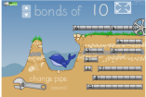  https://www.ictgames.com/saveTheWhale/index.html  Extra: Write down all the number bonds to 10 using the part-whole model. E.g  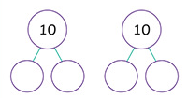
Wednesday | Task 1: Look carefully at this photo again. Here are the names of the people in it. Can you find them in the picture?  Princess Margaret Winston Churchill Princess Elizabeth  Queen Elizabeth (the queen’s mother) King George VI  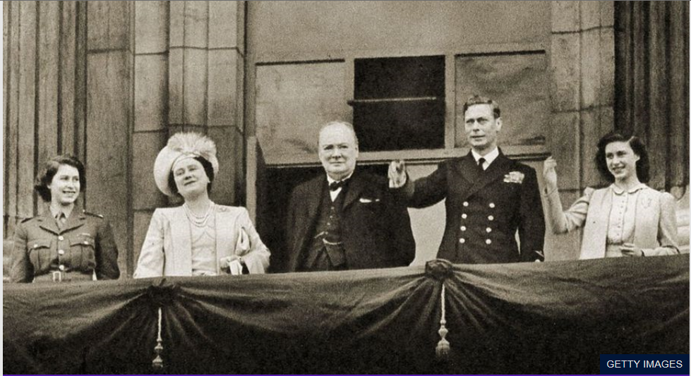  Task 2: Draw the picture and label the people who were on the balcony at Buckingham palace. | Number bonds to 20  Can you tell your families… some of the number bonds to 20 (numbers that add together to make 20)  e.g 0 + 20 = 20 1 + 19 = 20  Task: Play ‘Spring number’ game.  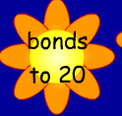  https://www.topmarks.co.uk/Flash.aspx?f=SpringNumber  This time find out what numbers make 20.
Thursday | Task: Make an acrostic poem for VE day.  e.g.  Victory in the war  Everybody was so happy that they  Danced in the streets  And had street parties  Yes they shouted the war in Europe is over! | Number bonds to 20  Task: Play ‘Hit the Button’ game. https://www.topmarks.co.uk/maths-games/hit-the-button  Click on the green ‘Number Bonds’ button.  Try these 2 games to play.
Friday | Task: Look at these special words from VE day. Can you tell your family what they mean?  Victory Celebrations King War Cheered  Prime Minister Street Party Buckingham Palace  Extra: Choose your favourite word and make an acrostic poem about VE day. | Number bonds to 20  Task: write down the number bonds to 20 using the part-whole model.  e.g.

