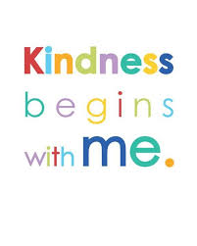

Use the following “Look, Cover, Write & Check” game to practice your spellings at home. You may either choose patterns or tricky words to work with!

<http://www.ictgames.com/mobilePage/lcwc/index.html>

Use the link to access free Oxford Owl books for children. You will need to create a username and login to access the books.

I would like the children to read “Stories of Sherlock Holmes” and “Exploring the Deep”

<https://www.oxfordowl.co.uk/for-home/find-a-book/library-page>

Our theme for the next two weeks is Kindness and people who help us! We are going to look at people who help us, are kind to us and how we can help them.

Don’t forget, I love to hear how you are getting on with your home learning!

If you have any questions or would like to show me how you are doing with your home learning, please email me at

[a.mcphail300@durhamlearning.net](mailto:a.mcphail300@durhamlearning.net)

Please use the links on this page to access reading and spelling resources!

It is just as important to practice our reading and spellings whilst we are learning from home!

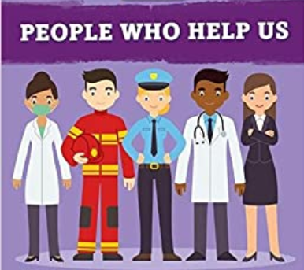

Over time there have been lots of scientists that have made very helpful discoveries! One of these scientists is Alexander Fleming – his discovery changed medical practice forever (even though he discovered it by accident!). Create a short biography about Fleming, explaining what he discovered and why it has been so helpful!

<https://www.bbc.co.uk/bitesize/clips/zd2qxnb>

Create a piece of art around the theme “people who help us”. You can use whatever medium (art supplies) you wish!

People who help us -Kindness

Activities

Week beginning 11th May 2020

Write a character description of a nurse using adjectives to describe them. What kind of characteristics do you think you need to have to be a good nurse? Think about the kind of person Florence Nightingale was and any nurses you know in real life. 

Complete the reading comprehension about Florence Nightingale (Please see “People who help us resources). You can write the answers straight into your book.

“I think it is important to take part in Clap for Carers on Thursday evenings”

Do you agree or disagree? Give reasons for your answer.

Challenge: Can you write points for and against the statement?

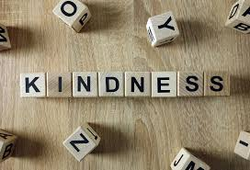

In the “People who help us resources”, there is a list of jobs in French. Pick 5 helpful jobs, write them out and illustrate what the people doing the jobs would look like (e.g. a nurse in uniform)

Have a look at the “Kindness Calendar” in the “People who help us resources”. Can you fill the full calendar with acts of kindness? When you do something that is kind, write it into your calendar. You can make and decorate your own for your book!

Design an award that can be given to people who are very kind (e.g. Captain Tom Moore). Think about what it will be made from, why it is important to recognise kindness and what people need to have done to earn one of your awards!

Create an acrostic poem for the word kindness (Each line needs to start with the letter at the front of the line). Remember, acrostic poems don’t have to rhyme!

K

I

N

D

N

E

S

S

People who help us -Kindness

Activities

Week beginning 18th May 2020

I would like you to think of 20 acts of kindness you could do to make someone feel valued (there are some ideas in the “People who help us resources” if you need inspiration)