Hello everyone!
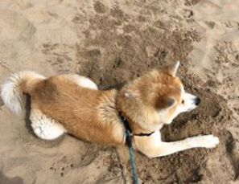
I hope you are all doing well. It feels like ages since I last saw most of you! I’ve been working hard to get home learning jobs sorted for all of you whilst working with the children of Key Workers in school. I’ve also been helping an older person look after their dog – his name is Mooshi and he is good fun!
I am just writing to let you know that we are going to continue having planning “themes”. Everyone I have spoken to has really enjoyed the VE Day learning and it means that we are doing similar work to other children in school (which you may have noticed if your brothers and sisters go to our school). Your next set of Home Learning may seem like a lot more but it is meant to be done over two weeks rather than 1. As always have a go at the home learning and let me know by email if you need a hand with any of it.
Our next theme is kindness, as it is very important at times like these to keep on being as kind as we can. There is a special focus on people who help us as well, as we may need their help now more than ever. Please send me any work you would like to show me to a.mcphail300@durhamlearning.net
I have missed working with all of you over the past few weeks and I can’t wait to see you all again once it is safe to do so.

Keep safe and keep up the hard work,

Mr McPhail

