Religious Education

Year: Class 3     Teacher: Miss Brack Week Beginning: 4th May 2020

Our RE topic for this half term focuses on Pentecost and how we can show if we have an attitude of service by the way we live our lives, the way we treat others, and by our words and actions.

We will look at the power of fire and wind and how this energy can be used for good before we learn more about Pentecost and the gifts given by the Holy Spirit.

This week I would like you to think about the gifts from the Holy Spirit.

Look at the gifts of the Holy Spirit using the Powerpoint 1 and 2. How can people use their gifts to serve others? Create a simple poster drawing pictures of how can we use these gifts.

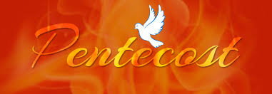Don’t forget to email me your good news when you have finished – [j.brack300@durhamlearning.net](mailto:j.brack300@durhamlearning.net)