**PE**

The Potato Race

Learn how to play a typical Victorian outdoor game.

<http://www.judgeslodging.org.uk/resources/victorian_outdoor_games/>

What is your quickest time to complete the race?

.

**Music**

Learn about dynamics by working your way through the information and videos.

<https://www.bbc.co.uk/bitesize/articles/z6bpf4j>

**PHSE**

Learn about the work of Dr Barnardo, who lived around the same time as William Morris.

<https://www.bbc.co.uk/teach/class-clips-video/true-stories-thomas-barnardo/zky7pg8>

Think about how people have different lives and how individuals can help other when they need it.

**Art**

Have a look at some of William Morris’ artwork

<https://primarysite-prod-sorted.s3.amazonaws.com/lionel-primary-school/UploadedDocument/610f68acbf274a1cb4326f27a9972077/william-morris-slide1.pdf>

Create your very own wallpaper design based on plants and animals.

**DT**

Make your own mini garden.

https://www.wmgallery.org.uk/media/_file/learning/wmg-learning-at-home-activity-sheet-make-your-own-mini-garden.pdf

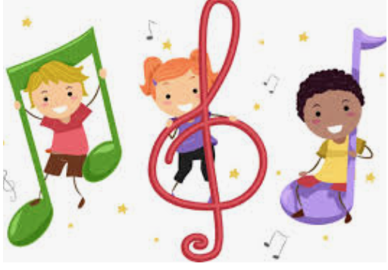

**English**

*Comprehension* - Answer the questions about Victorian inventors in your book (Victorian Inventors).

*Spelling*- Year 3 and 4 words

<https://spellingframe.co.uk/spelling-rule/73/35-Word-list-years-3-and-4---t-to-w>

*Grammar* - Using Paragraphs

<https://www.bbc.co.uk/bitesize/topics/zvwwxnb/articles/z9n73k7>

Now have a go at this online paragraphs quiz

<https://www.educationquizzes.com/ks2/english/paragraphing/>

*Writing* - Write a biography about William Morris.

Below are a couple of websites that you could use to help -

<https://primaryfacts.com/143/william-morris-facts/>

<https://kids.kiddle.co/William_Morris>

Think about where he was from. What he did? Why did he think it was important to draw from nature and from first-hand experience? Remember to use paragraphs.

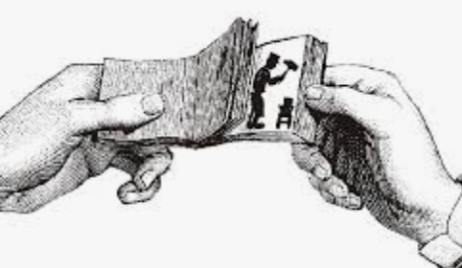

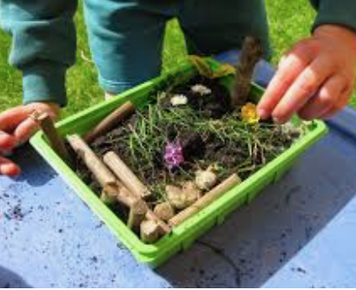

**History**

Find out about an invention from the Victorian Era, for example - telephone, electric light bulb, car, railways, sewing machine, typewriter, etc. Research how it has changed over time by finding or drawing pictures of the changes to create a timeline. Think about how the invention helps people in their lives today.

**Computing**

Victorians used flickbook animations. Learn about them here -

<https://www.bbc.co.uk/bitesize/clips/zc96nbk>

<https://www.youtube.com/watch?v=JVzf9rtgf9Y>

Use <https://flipanim.com>

to create your own moving flipbook animation.

**Science**

WClassifying animals

<https://www.bbc.co.uk/teach/class-clips-video/science-ks1-ks2-ivys-plant-workshop-grouping-living-things/zfjxcqt>

Name the animal groups and write what the animals in that group have in common. (see resources).

**Reading**

Read Great Artists on oxford Owl.

<https://www.oxfordowl.co.uk/api/digital_books/19684.html>

**Geography**

Find your way around the UK, using a map to give directions.

<https://12ee0b5a-abb3-9812-7a54-6dc8dc507f17.filesusr.com/ugd/5cd6ef_9a47d9f1f69a6ae1b0f2ad21580df634.pdf>

Activities WB 1.6.2020/ 8.6.2020

Our theme for the next fortnight is ‘Famous Artists’

Work through it at your own pace.

We will be focussing on William Morris and his life and amazing artwork he has created.

