PHSE

Look at the two pieces of Lowry artwork in the resources area.

Which of the two paintings do you prefer and why?

Put yourself into the shoes of one of the matchstick men in both paintings. How do you think they would be feeling?

Create two spider diagrams to show the different feelings of the people in the paintings (see the resources for an example).

Art/DT

Try and create a matchstick figure like one a Lowry figure. You can do it as a self-portrait or a family member or friend.

Using the resources try to create a picture in the style of Lowry. I would like you to try and create a seaside picture.

Imagine our school at playtime. Can you create a Lowry style picture called “Playtime” to show what it would be like?

Create a piece of art that shows the view of your street/your local area.

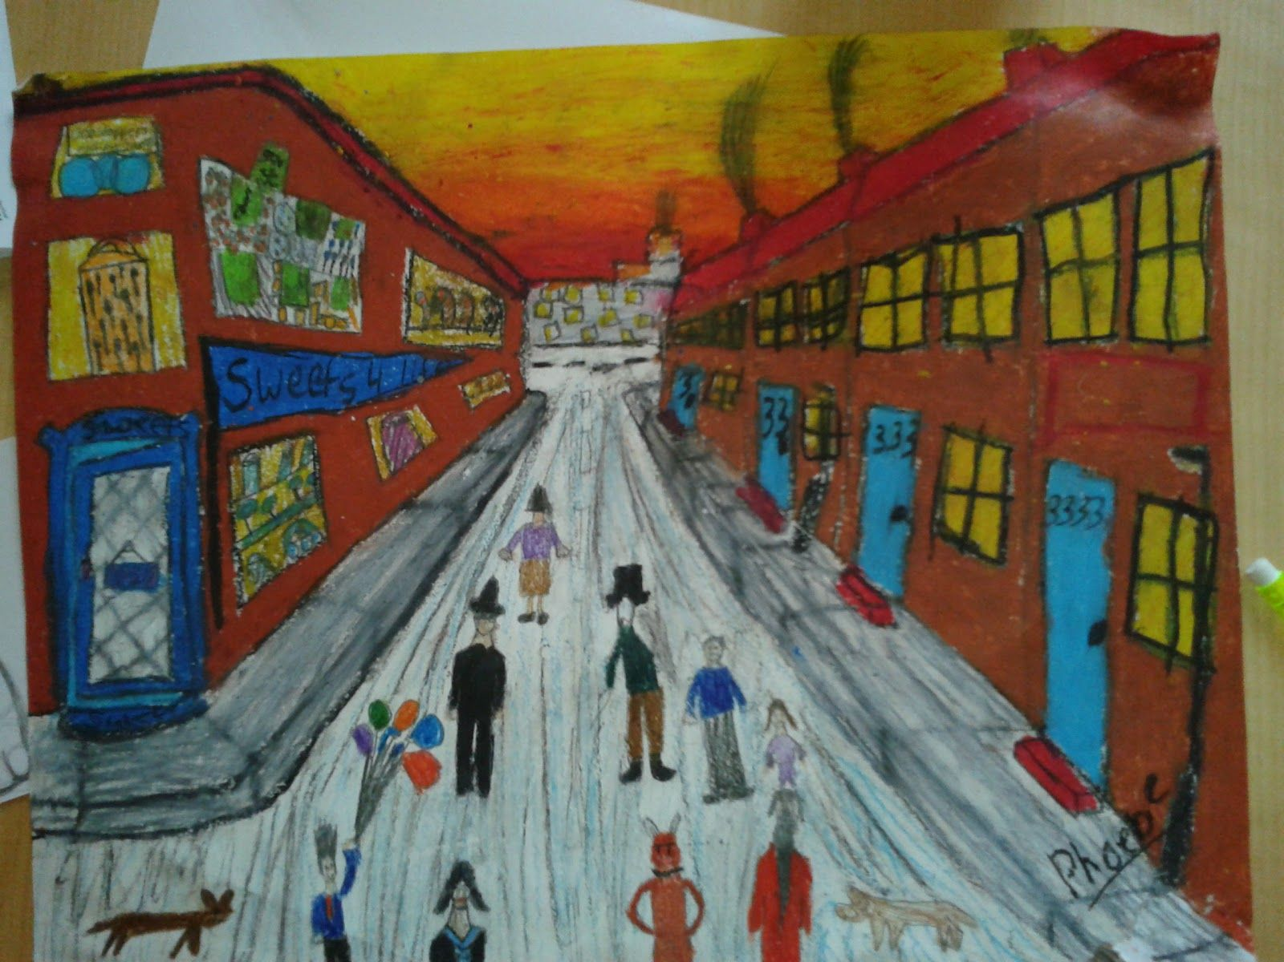

Music

Lowry’s paintings were so realistic you could almost hear them!

Listen to the following tracks for a few minutes:

<https://www.youtube.com/watch?v=2V0hLayHrN4>

<https://www.youtube.com/watch?v=b0OByTvG8Mo>

Look at the Lowry paintings in the resources area. Write a short paragraph about how each piece of music/artwork makes you feel.

PE

Lowry was active during WWI and WWII. During this time fitness was important. In the resources, I’ve included the fitness test scores to join the British Army in WWII. How close can you get to the targets? Can you beat any of them?

Geography

Lowry painted seascapes and beaches. Do you know how beaches are made? <https://www.bbc.co.uk/bitesize/clips/zc2pvcw>

Draw a diagram to show the different sizes and shapes of rocks during different stages of erosion (see resources).

English

Create a biography about L. S. Lowry. You need to talk about his personal life, his famous paintings and any interesting facts that you can find!

<https://www.bbc.co.uk/bitesize/clips/z3gkq6f>

<https://primaryfacts.com/2248/l-s-lowry-facts-and-information/>

**Spelling**

Use the following “Look, Cover, Write & Check” game to practice your spellings at home. You may either choose patterns or tricky words to work with!

<http://www.ictgames.com/mobilePage/lcwc/index.html>

**Grammar**

Using similes and metaphors.

<https://www.bbc.co.uk/bitesize/articles/z4nybdm>

Using prepositions in writing.

<https://www.bbc.co.uk/bitesize/articles/zbkwqp3>

Activities WB 1.6.2020/ 8.6.2020

Our theme for the next fortnight is ‘Famous Artists’

Work through it at your own pace.

We will be focussing on L.S. Lowry, his life and his amazing artwork!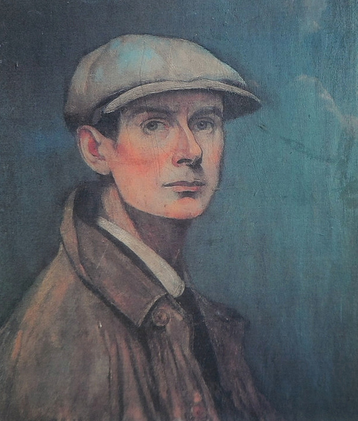



History

What questions would you ask Lowry? Think about the pieces of artwork he created and what you might ask him about them.

<https://www.bbc.co.uk/teach/class-clips-video/art-and-design-ks2-ls-lowrys-britain-at-play/zvkskmn>

Lowry often painted busy industrial scenes, showing lots of people in a bustling city environment. What do you think it would be like to live in an area that Lowry painted? Can you think of good points and bad points?

Science

Lowry paintings do not include shadows. We know from science lessons that shadows are caused by blocking a light source.

Have a go at making a sundial to track shadows! (see resources)

Reading

Read Great Artists on oxford

owl.

[Oxford Owl](https://www.oxfordowl.co.uk/for-home/find-a-book/library-page/?view=image&query=&type=book&age_group=Age+7-9&level=&level_select=&book_type=&series=)

<https://www.oxfordowl.co.uk/api/interactives/24642.html>

ICT

Use your computer to try and create an image like a Lowry painting.

You can use a drawing app on your computer or tablet (or use the below link to access a free version)

<https://kidmons.com/game/paint-online/>