Science
To make a sundial all you need is a pencil/pen or a stick!
Stick the object into the ground – this needs to be in a sunny area and is best outside!
As the day progresses, have a look at the shadow to see where it points. What do you notice as the day progresses?

Geography
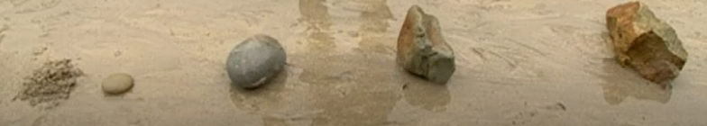
You can use this image as an example to show how rocks change size and shape as they are eroded (worn down) by water.
Have a go at drawing your own version of this!

PE
For the following exercises record how many you can do in 2 minutes
If you want to make it more of a challenge, a top WWII would need to do at least 100 of each (with no time limit)
Squat jumps
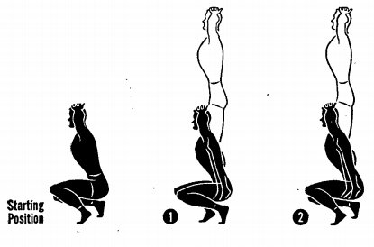

Sit ups
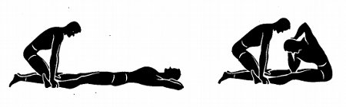

Star jumps
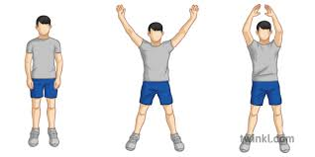
And finally running on the spot as quickly as you can (aim for 30 seconds to start with).
I would also recommend doing “PE with Joe Wicks” each day to maintain fitness!
https://www.youtube.com/channel/UCAxW1XT0iEJo0TYlRfn6rYQ

Music & PSHE
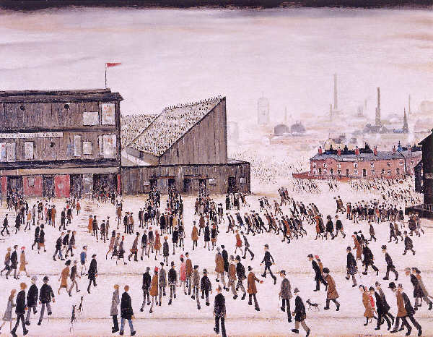
This piece of artwork is one of Lowry’s city paintings. Listen to the first track whilst you study it!

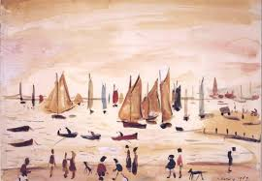
This piece is one of Lowry’s beach scenes. Listen to the second track whilst you study it!

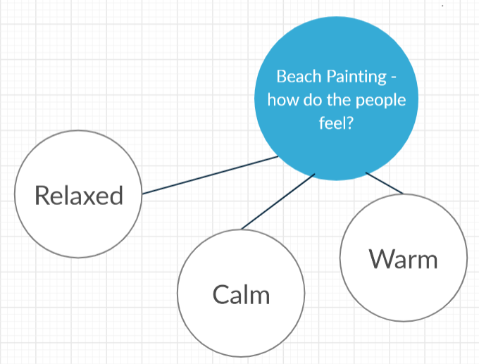
Example spider diagram for the PSHE task

Art
