Dear Class 3,
I hope you and your families are all healthy and staying safe. I am missing you all very much, especially your smiley faces, wonderful work ethic, your laughter in the classroom and even your daily jokes and riddles for me to solve!
You have all had home learning packs to keep you busy but I understand that this time is very different and can be confusing for you so I hope you are having time to relax, have fun and enjoy the sunshine! I’ve enjoyed spending time with my family and taking long walks with my dogs.
Now, I’m sure you are all being superstars for your adults but remember to listen to what you are being told to do, make people smile and do what you know is right!
After Easter, I will be uploading work for you to complete each week. There will be a daily Maths and English for you to complete. There will also be a challenge option for the maths activity as I know some of you will want to challenge yourselves! This will be on our school website.
I will also be uploading a ‘Home Learning Menu’ style grid with lots of fun and different activities for other subjects. Don’t worry, you will not have to complete these every day! You can choose 3 activities to complete each week. If you find something difficult, don’t panic! Remember we don’t give up, keep showing resilience! Even though I can’t be with you right now, don’t forget I still believe in you and you CAN do it!
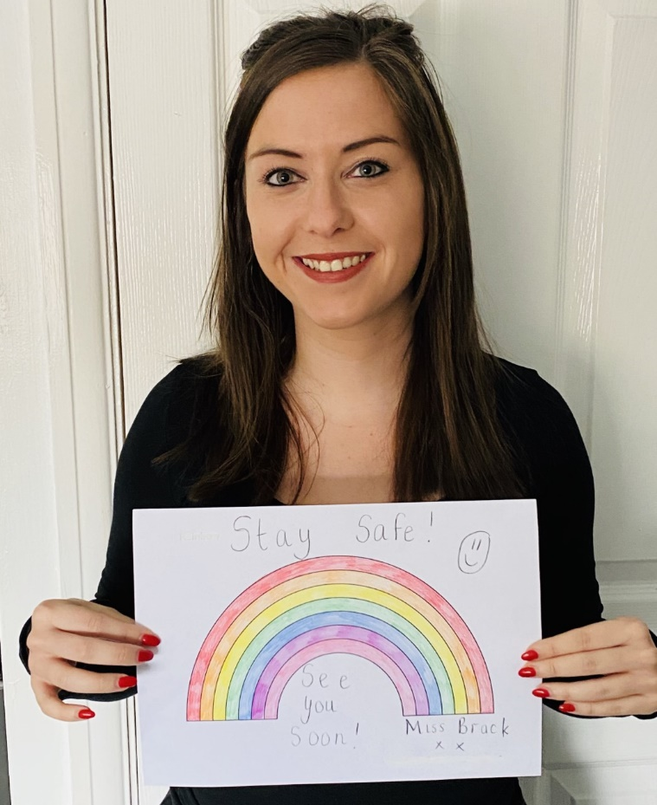
As I am missing seeing your fantastic work, my school email is j.brack300@durhamlearning.net and this will be added to the website for you to send me examples of your hard work or if you have any questions! We now have a ‘Class Gallery’ page where I can upload the photographs or work you send me so all of your friends can see too – how exciting! I can’t wait to see and hear about the things you have been up to!
I really hope to see you in school again soon!
Take care, stay safe and keep smiling!
Miss Brack

