Religious Education
Year: Two Teacher: Miss Harker Week Beginning: 27th April 2020

Our RE topic for this half term focuses on Pentecost and how we can share Jesus’ Good News.
We will learn more about Pentecost which is a time to celebrate the Good News of Jesus.

This week I would like you to read the story John 13 and answer the questions below:

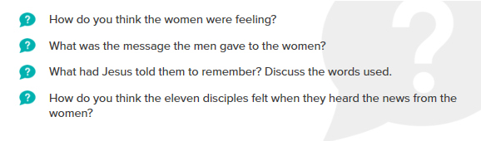
Now that you have thought about the women and the message they were told. Think about the special news the women told the disciples. What words do you think they used and how do you think they felt? Role play the story. Take a picture or video if you like!
Using a template of a newspaper report write an article called Jesus is risen!
Don’t forget to email me when you have finished – y.harker300@durhamlearning.net

