j0293844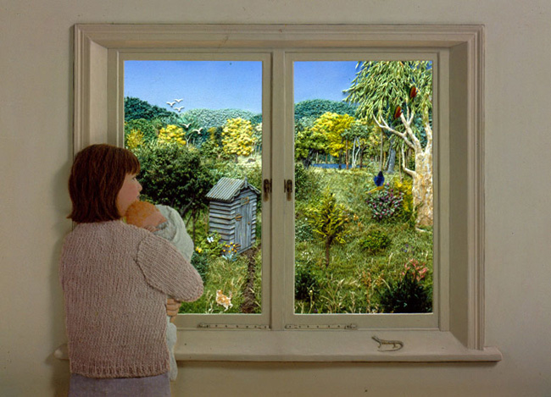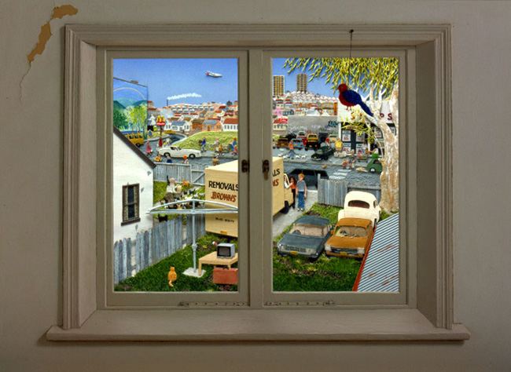

How do the changes make you feel?

What do you notice about the view through the window? How has it changed?

____________________________________________________________________________________________________________________________________________________________________________________

Why do you think this has happened?

________________________________________________________________________________________________________________________

I can name physical and human features.

I can spot changes that have happened over time.

Compare the views from Jeannie Baker’s book “Window”. Human features are things changed by humans. Physical changes happen naturally.

**Human**

________________________________________________________________________________________

**Physical**

________________________________________________________________________________________

**Human**

________________________________________________________________________________________

**Physical**

________________________________________________________________________________________

**Approximately 20 years later...**