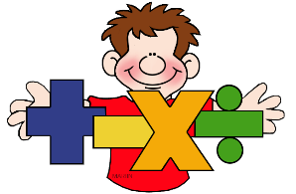
English and Maths

Year:__2____ Teacher:_Miss Harker Week Beginning:_27.04.20________
Weekly Reading Task: | Choose a story you have at home or from the websites below and write a book review about your chosen book.  https://www.booktrust.org.uk/books-and-reading/have-some-fun/storybooks-and-games/  https://www.freechildrenstories.com/age-5-8-1  Phonics games can be found at https://www.phonicsplay.co.uk/  https://www.phonicsbloom.com/
 | English Activity/ Objective | Maths Activity/Objective
Monday | Task 1:  Watch Supertato to write a character description!  https://www.youtube.com/watch?v=rze89HB9u8g  Create your very own superhero character to save the day. Draw and describe your character. Use adjectives and interesting punctuation to describe your character (commas in a list, exclamation marks).  https://home.oxfordowl.co.uk/blog/4-fun-ways-to-develop-characters-for-a-short-story/ | Task 1:  Mental Maths: https://www.topmarks.co.uk/ordering-and-sequencing/caterpillar-ordering Go as tricky as you want!  Equivalent fractions  Find different things you can use to prove that a half is equal to 2 quarters.  Cut a pizza/cake, share raisins, grapes, lego out into halves and quarters.  Link to video on fractions equal to a half:  https://www.youtube.com/watch?v=ieT9k537jP4&list=PLWIJ2KbiNEypS0zxt54Wez5X4gnQ-xxvu&index
Tuesday | Task 2: Create a setting for your character! Where will your story happen? Use pictures, go outside collect things to create your setting, use empty yoghurt pots, twigs, leaves, lego, anything you have in your home!  Use adjectives to describe your setting!  Send pictures of your amazing settings!  https://www.bbc.co.uk/bitesize/topics/zpccwmn/articles/z8mqsrd | Task 2: Finding three quarters.  Mental Maths: https://www.topmarks.co.uk/maths-games/hit-the-button  Try up to 20!  Find three quarters of different amounts. Use anything you have in your home like spoons, leaves, stones, lego, marbles, grapes.  Start by finding one quarter then 2 quarters and then three quarters. Remember they need to be equal groups!  Use the video from Summer Week 1 Lesson 1.  https://whiterosemaths.com/homelearning/year-2/
Wednesday | Task 3: To identify verbs, nouns, adjectives and adverbs.  https://www.youtube.com/watch?v=7zRih61HCZs  Can you make a list of each word class? For example, Adjectives – big, huge etc  Then put your super vocabulary into a sentence!  Noun adverb verb adjectives noun  The boy slowly opened the creaky, black and heavy door. | Task 3: Counting in fractions.  Can you use everyday objects to count in thirds like the video? How may thirds can you count to? More than 12?  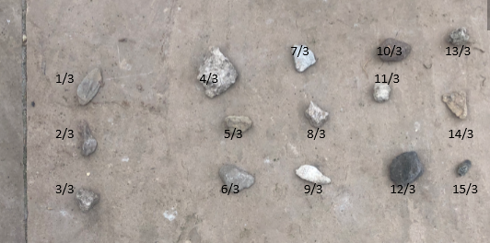  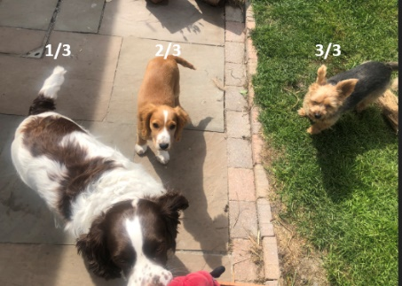  Can you challenge yourself to count in quarters? Can you write the fraction underneath?  Summer week 1-Lesson 2  https://whiterosemaths.com/homelearning/year-2/  Mental Maths : https://www.topmarks.co.uk/learning-to-count/place-value-basketball
Thursday | Task 4: To plan an adventure story where your superhero solves a problem and saves the day!  You need a beginning (introduce setting and characters!)  Middle (problem)  End (How is the problem solved?)  Try to use as many of the different word classes as possible in your plan to help you and some fabulous pictures to help you plan your story map!  Use Supertato for inspiration! https://www.youtube.com/watch?v=rze89HB9u8g | Task 4; Number bonds to 10  Practise your number bonds to 10 by playing the Total of 10 and the ‘Make 10’  pyramid card game.  Link to the ‘Total of 10’ card game:  https://www.youtube.com/watch?v=SD028NO-ZGc&list=PLWIJ2KbiNEyoBDc5yLJ4PaiaY3o5E5xCB&index=5&t  Link to the ‘Make 10 Pyramid’ card game:  https://www.youtube.com/watch?v=3IFFRWkMWGk&list=PLWIJ2KbiNEyoBDc5yLJ4PaiaY3o5E5xCB&index  Can you make up your own game to practise number bonds to 10?
Friday | Task 5: To write your own adventure story where your superhero saves the day!  Use your plan from yesterday and remember we need:  Beginning (introduce setting and characters!)  Middle (problem)  End (How is the problem solved?)  Make sure to use interesting vocabulary! Adjectives, adverbs, conjunctions.  https://www.bbc.co.uk/teach/supermovers/ks1-english-adjectives-adverbs-with-johnny-inel/znfjbdm  Use some interesting punctuation like commas in a list, exclamation mark, question marks, full stops.  https://www.bbc.co.uk/teach/supermovers/ks1-english-punctuation-with-karim-hacker/zrksqp3 | Task 5:  Mental maths: https://www.topmarks.co.uk/maths-games/hit-the-button pick the 2x table.  Complete the challenges 1,2,3  https://wrm-13b48.kxcdn.com/wp-content/uploads/2020/04/Family-Challenge-Friday-24th.pdf  If you want more challenge continue to do as many as you can!

