Weekly Reading Task: | Each day play a read the word game https://www.phonicsplay.co.uk/  Each day recap the Phase 3 and Phase 5 sounds and play the games https://www.bbc.co.uk/bitesize/topics/zvq9bdm  https://www.phonicsplay.co.uk/PicnicOnPluto.html
 | English Activity/ Objective | Maths Activity/Objective
Monday | 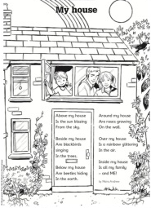  Poetry: ‘My House’ by Moira Andrew  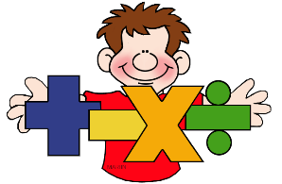  English and Maths  Y1 Miss Jewitt Week Beginning: 27th April 2020  Task: Read the poem with your family. (at the bottom of this document)  What was your favourite verse?  Can you write down your favourite verse and draw a picture of it.  E.g  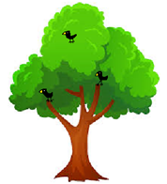  Beside my house  Are blackbirds singing  In the trees. | Money- Recognising and sorting coins:  Can you tell your families… What do we need money for?  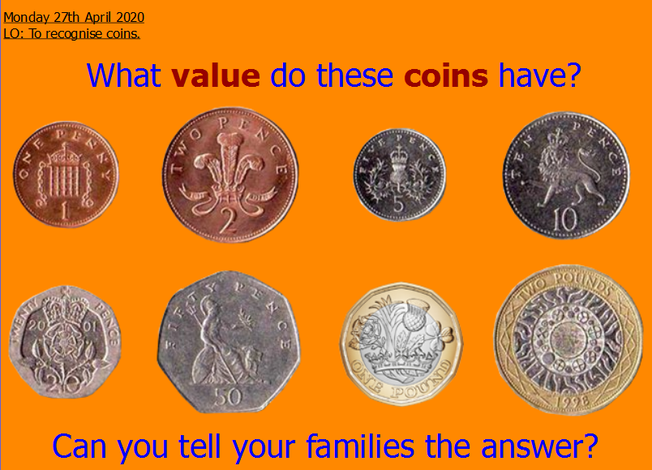  Task: Play ‘The Coins Game- Sorting’ https://www.topmarks.co.uk/money/coins-game  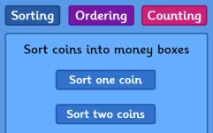  Can you sort the coins into groups? First try with one coin and then have a go with two coins – Good Luck Year One!  Extra: Make some coin rubbings – can you label each coin?  e.g = £1
Tuesday | Task: Read the poem with your family again - can you find any words that end with ‘ing’? Write them down.  Stand up and find a space to work out with Jack Hartman.  https://www.youtube.com/watch?v=j3EYciNco58  Choose 3 of your favourite of Jack’s verbs then add ‘ing’ to them. Can you write a sentence using your ‘ing’ word?  e.g gallop = galloping.  The beautiful brown horse was galloping around the green field. | Money- Ordering coins:  Task: Play ‘The Coins Game – Ordering.  https://www.topmarks.co.uk/money/coins-game  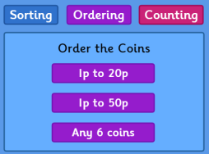  Can you order the coins from the lowest to the highest value? Good Luck Year One!  Extra: Which is your favourite UK coin? Look at it carefully – Can you draw a picture of the front and the back of it?
Wednesday | Task: Look carefully at the poem again – notice how each of the six verses start.  e.g  Above my house… 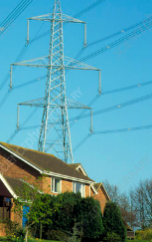 Beside my house… 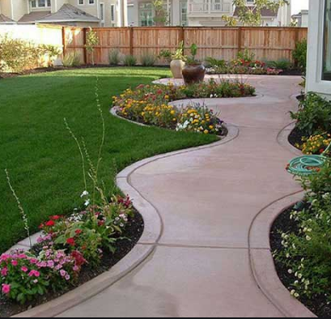 Below my house… 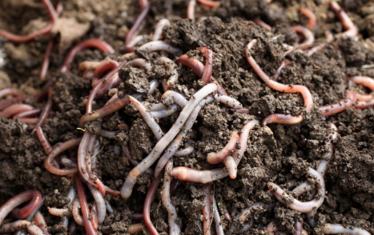  Around my house… Over my house… Inside my house…  Think about your house, draw a picture for each verse: something that is above your home, beside your home, below your home etc.  Extra: Think of adjectives to describe what you can see e.g. long, black wires, Curvy grey path, tiny pink worms etc | Money- Counting coins:  Task: Count in 1’s, 2’s and 5’s to help you find out the total of the coins. Good Luck Year One!  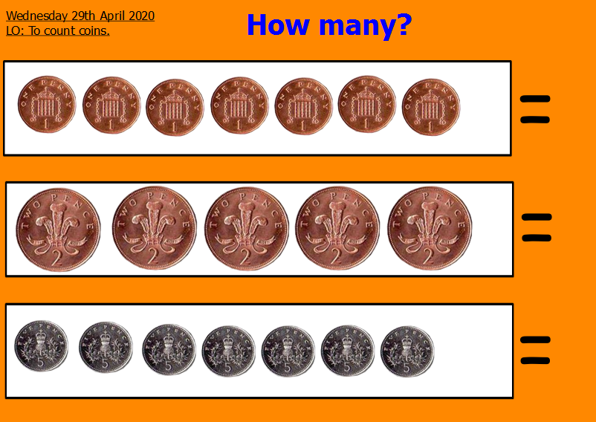  Extra: Can you find any 1p, 2p, 5p or 10p coins in your house? Can you count how much?
Thursday | Task: Using your pictures from yesterday start to write your own MY HOUSE poem. Write the first 3 verses today.  e.g. Above my house  Are long, black wires swaying  In the sky  Beside my house  Is a curvy grey path curving  Up to my front door | Money- Counting coins:  Task: Play ‘The Coins Game – Counting.  https://www.topmarks.co.uk/money/coins-game  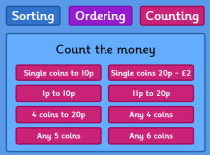  Can you count the coins?  Good Luck Year One!  Extra: Make a toy shop in your house. Label the toys to say how much they cost.
Friday | Task: Using your pictures from Wednesday, finish writing your own ‘MY HOUSE’ poem. Write the final 3 verses today. Read your MY HOUSE poem to your family.  I can’t wait to read them!  Extra: Illustrate your poem. | Money- Ordering coins:  Task: Play ‘The Custom Car Garage game’  https://www.ictgames.com/mobilePage/customCars/index.html  Make your perfect car by counting money to pay for each item. Good Luck Year One!  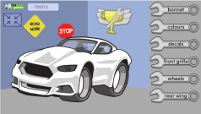  Extra: Play in your toy shop or make another shop in your house e.g food shop. Don’t forget to label the items to say how much they cost.

